Zion Cawthon
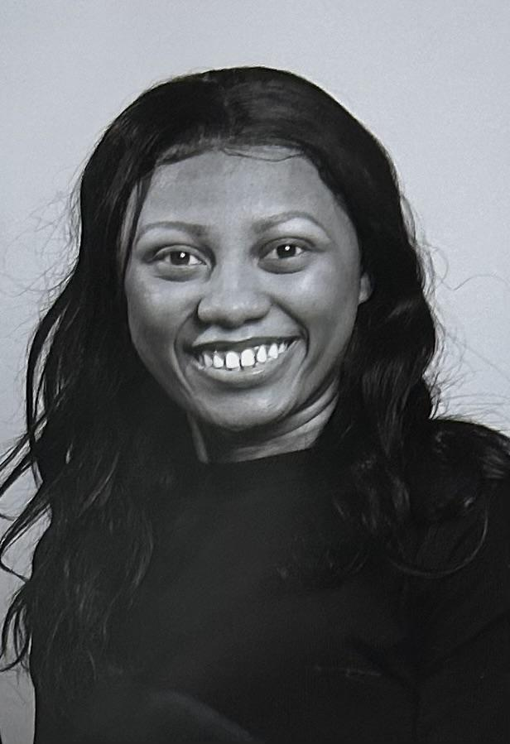 | Email: zion.cawthonofficial@gmail.com  Phone: 678.913.9953  Instagram: Zion.c14  Height: 5’2 Hair: Dark Brown Eyes: Brown
Theatre | Show Role  Good Man Charlie Brown Kid/Ensemble Creekview Productions Dir.Elizabeth Crane  Once Upon A Mattress Princess 12 Creekview Productions Dir. Elizabeth Crane  Aladdin Featured Dancer Webb Bridge Kids Dir. Amy Creamer  Chicago Reporter/ Ensemble Alpha Theatre Dir. Sarah Stoffle-Peck  Footloose Teen Dancer/Ensemble Alpha Theatre Dir. Sarah Stoffle-Peck  Great Gatsby Ensemble Alpha Theatre Dir. Sarah Stoffle-Peck  Our Place Ensemble/Molly Alpha Theatre Dir. Sarah Stoffle-Peck  Into The Woods Ensemble Alpha Theatre Dir. Sarah Stoffle- Peck  39 Steps Mrs. Memory Alpha Theatre Dir. Sarah Stoffle Peck  Addams Family Grandma Addams Alpha Theatre Dir. Sarah Stoffle-Peck
Film  Choir  Training  Special Skills | Name Role  The Lost Girls Mary Darling AHS Film Dir. Student Produced  2015-2016 Elizabeth Crane  2017-2018 , 2018-2019,2019-2020 Caroline Reitzes  2023-2024- Michelle Austin  Acting  Atlanta Workshop Players 2015  Musical Theatre I Sarah Stoffle Peck 2020-2021  Musical Theatre II Sarah Stoffle- Peck 2021-2022  Musical Theatre III Sarah Stoffle- Peck 2022-2023  Advanced Acting I Sarah Stoffle-Peck 2023-2024  Dance Fleetwood Dance Tap, Ballet 2018  Singing Carrie Bell 2023  Sports  WinterGuard Kaleigh Schlosser 2017-2018, 2019-2020  Cockney Accent, Juggling and Singing.

