**Everette Street** [**everette.street@yahoo.com**](mailto:everette.street@yahoo.com) **904-982-6580**

**Performance Experience**

**Theatre**

***Le Chat Noir Christmas Show – Dad/Toy Company Exec***

Le Chat Noir, Augusta, GA

2023 – Krys Bailey, Director  
  
***Ghosts & Gravestones – Charlie/Executioner/Ghost Host***

Old Town Trolley, St. Augustine, FL

2014- 2018 – Noble Lester, Director

***The Curious Incident of the Dog in the Night Time – Ed Boone***

Players By The Sea, Jacksonville Beach, FL

2018 – Bradley Akers, Director

***The Christians – Pastor Paul***

Limelight Theatre, St. Augustine, FL

2015 - Richard Curran-Kelley , Director

***Sweet Bird of Youth – Fly/Heckler/Charles***

Limelight Theatre, St. Augustine, FL

2015 - Gary Cadwallader, Director

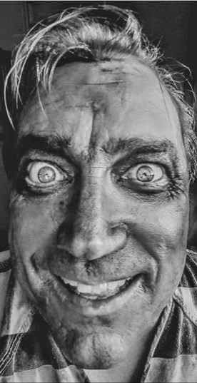***The Best Christmas Pageant Ever – Dad***

Atlantic Beach Experimental Theatre (ABET), Atlantic Beach, FL

2012 - Celia Frank, Director

***God of Carnage – Michael***

Atlantic Beach Experimental Theatre (ABET), Atlantic Beach, FL

2012 – Eric DeCicco, Director

***Duck Hunter Shoots Angel – Lester*** Limelight Theatre, St. Augustine, FL

2011 – Lorraine Portman, Director

***Superior Donuts – Luther***

Players By The Sea, Jacksonville Beach, FL

2011 – Jason Collins, Director

***Second Samuel – Frisky Madison*** Limelight Theatre St. Augustine, FL

2011 – Stephen Pigman, Director

***The Passion / Last Hours With Christ – Peter, Pilate*** Daybreak/Christ Episcopal Church Ponte Vedra Beach, FL

2000-2011 – Malinda Harris, Director

**Musical Theatre**

***Carnival of the Animals -- Narrator***

St. Augustine Music Festival, St. Augustine, FL

2018 – Camille Saint-Saens, Composer, Jorge A. Pena, Artistic Director

***The Rocky Horror Show Live – Narrator***

1904 Music Hall, Jacksonville,FL

2017 – Samuel Fisher,Director

***The Full Monty – Dave Bukatinsky*** Limelight Theatre, St. Augustine, FL

2017 – Beth Lambert,Director

***Spamalot – Bedevere/Mrs. Galahad/Concorde***

Limelight Theatre, St. Augustine, FL

2013 - - Gary Cadwallader, Director

***Joseph And The Amazing Technicolor Dreamcoat – Asher***

Christ Episcopal Church, Ponte Vedra Beach, FL

2011 - Pherbia Engdahl, Director

*Ghosts & Gravestones – Charlie Powell*

**Everette Street**

**Height: 5ft 7in Weight: 185lbs Hair: Blonde Eyes: Blue**

**Voice**

**Tenor - Low C4 to HighE6**

**Special Skills/Additional Information Basic stage choreography**

**Basic stage combat Juggling**