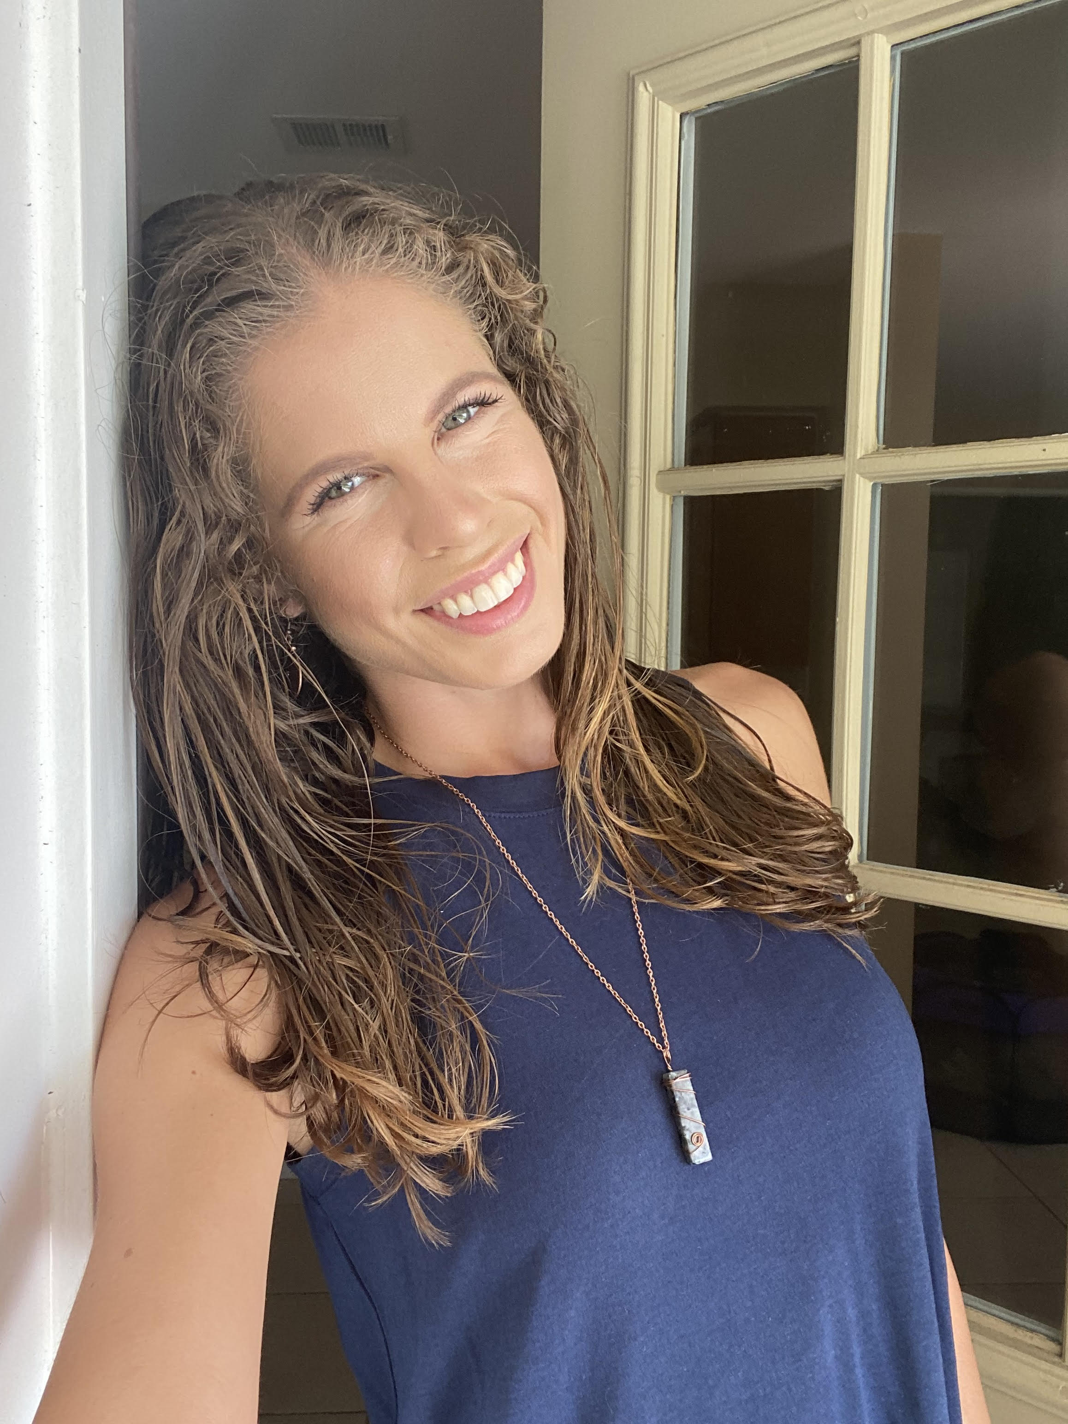 |  | Bianca Dixon  Festival/Event Independent Contractor
Profile  Compassionate event professional who thrives under pressure and goes above and beyond to finish a job in a timely manner. With three years of leadership experience that includes staff management, development and over six years of customer service experience. Passionate leader and committed to achieving goals and helping others achieve theirs.  Contact  PHONE:  813-525-5401  EMAIL:  Biancadixon21@gmail.com  Skills  Self-Motivating  Team Player  Microsoft Office  Leadership  Marketing  Thrives Under Pressure |  | EDUCATION  Hillsborough Community College  8/2012 – 5/2016  Business Administration  3.5 GPA  University of South Tampa  8/2022 - Present  American Sign Language  WORK EXPERIENCE  Okeechobee 2020- Insomniac, Box Office  Super Bowl Experience 2021- BCForward, Supervisor  Bitcoin Miami 2021- The Trade Group, Production Assistant  Okeechobee 2022- Beatbox, Brand Ambassador  Innings Tampa 2022- Mad Merch, Merch  Coachella 2022- Merch  Hangout Fest 2022- Body Armor, Event Lead  Sunset Music Festival 2022- Box Office  Governor’s Ball New York 2022- Mad Merch, Merch  Bonnaroo 2022- Casa Bacardi, Manager  Electric Forest 2022- Autograph, Brand Ambassador  Rolling Loud Miami 2022- GoPuff, Event Lead  Lollapalooza Chicago 2022- Google, Event Manager  Advent Health Job Fair Daytona 2022- Production Assistant  Fresh Kitchen 2020-2021- Catering Manager  Volunteer Work  LYF Inc. School for Kids with Disabilities 2013-present  Beach Clean Up 2013-present  Feeding Tampa Bay 2017-present

