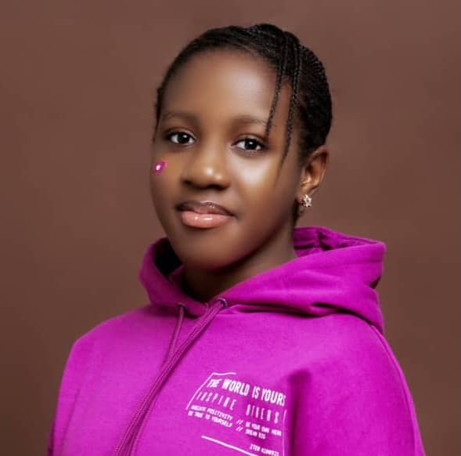  ELLA  SAMSON |  | AGE: 15  DATE OF BIRTH: 08092009  NATIONALITY: African descent, Nigerian.  WEIGHT: 55kg.  HEIGHT: 5’6.  EYES: Dark brown.  HAIR: Dark brown.  SKILLS: Bike riding, gymnastics, athletics, dancing, swimming, culinary skills.  EXPERIENCE: While there is no prior practical experience in acting, extensive training has been undertaken through acting classes. This pursuit has been supplemented by thorough and intensive research into acting techniques and methodologies. Such a comprehensive approach has provided a solid theoretical foundation, preparing the individual to apply these principles effectively in future acting endeavours.

Contact
PHONE:
+2349064073281

EMAIL:
ella.noyisam@gmail.com

