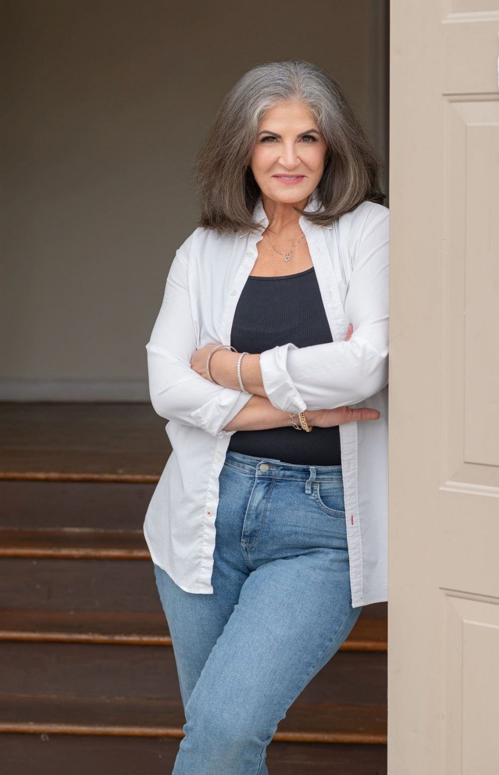
CYDNEE DUBROF
cydnee@dubrof.com
HEIGHT: 5’6” AGE RANGE: 50-60

TELEVISION & FILM
The Surgeon Background Dir: Pedro Gayo
EDUCATION & TRAINING
On Camera Basics Drama, Inc. Cat Dyer/Jason MacDonald
Master’s in Taxation Georgia State University
BA, International Relations Tufts University
SKILLS & INTERESTS

Mahjongg Maven
Georgia Driver’s License
Consummate Entertainer
Global Traveler (65 countries)

