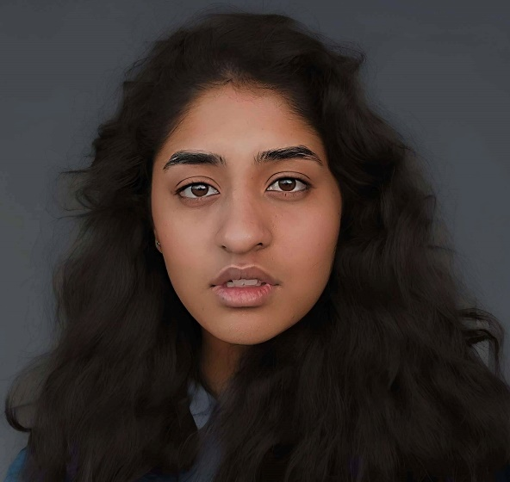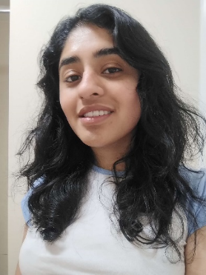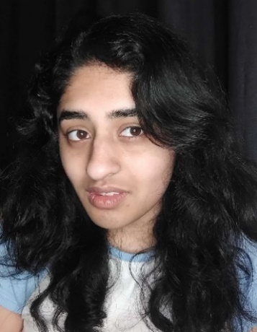

Herleen Sidhu

**CONTACT:** +44 7517 665647

**EMAIL:** [sidhuherleen18@gmail.com](mailto:sidhuherleen18@gmail.com)

**PHYSICAL ATTRIBUTES: .**

**HEIGHT:** 5’7” **AGE:** 22 (DOB: 18/09/2002)

**WEIGHT:** 65 kg **PLAYING AGE:** 15 – 40

**EYE COLOUR:** BROWN **VOICE PLAYING AGE:** 6 – 60+

**HAIR COLOUR:** BLACK

**SPECIAL SKILLS & EXPERIENCE: .**

* Improvised Acting, Voice Acting, Stand-in Acting, Comedy, Crying on Cue;
* Screenwriting, Filmmaking, Assistant Directing, Casting, Video Editing, Cinematography, Photography, Storyboarding, Audition Assistance, Set Design;
* Songwriting, Singing (Soul, Jazz, R&B, Pop, Rock), Backing Vocals, Amateur Guitar, Amateur Piano;
* Physics with Theoretical Astrophysics (University Level), Mathematical Skills, Chemistry, English, French, Punjabi, Graphic Design, Geography, Great Trivia Knowledge;
* Culinary Skills, Waitressing and Fine Dining, Computer Skills, Hospitality, Beginner Bartending, Money Management, Event Organiser, Analytical Skills, Outdoor Landscaping, Painting, Interior Designing, Engineering;
* Hockey, Table Tennis, Basic Swimming, Canoeing, Hula Hooping;
* Drawing, Painting, Fashion Designing, Photoshop, Cartoon Designing;

**TRAINING: .**

DIRECTING ACTORS BRITISH FILM INSTITUTE

ACTING ONLINE CLASS TOM LEVI

DRAMA CLASSES ADAM GOODGER

SCREENWRITING MOOC UNIVERSITY OF EAST ANGLIA

IMPROVISATION ACTING CLASS LEAH HANDLER

SCREENWRITING COURSE BRITISH FILM INSTITUTE

FILM INDUSTRY MULTISKILL COURSE BRITISH FILM INSTITUTE

**ACTING: .**

UNTITLED BBC SHOW EXTRA/SA - IN PROD.

UoN NIGHTLINE CAMPAIGN LEAD - PRE-PROD.

NIKE PROJECT - PRE-PROD.

BBC THE RESPONDER SEASON 2 EXTRA/SA - COMPLETED CHARLOTTE REGAN

UNTITLED FAITH FILM SINGER - PRE-PROD. OLEKSIY ANDRONYAK

OSORO STUDENT - COMPLETED SHEILA NORTLEY

INDUSTRY NETWORK PROGRAMME SELECTED

PROJECT PARASOMNIA PRISHA (voice) - IN PROD.

AFTON'S ANIMATRONICS UNTITLED SEQUEL SINGER - IN PROD.

TROLLBOY VILLAIN (voice) - POST PROD.

FREAKED FLEAPIT (voice) - IN PROD.

BRUISES CARLI - POST PROD. AARON MINSHUL

HE FOLLOWS WITH PRIDE STAND-IN MARC CARPENTER

URINETOWN MUSICAL (Theatre) STAND-IN

I have experience singing with small bands on stage and will be featuring on upcoming songs. I also have worked behind the scenes for theatre productions and short films and spoken on podcasts and radios.

**SCREENWRITING: .**

TOOTHPASTE – Won Best Screenplay for Young Writers, Offered to be Novelised, Selected by WideScreen Film & Music Video Festival

SO, BASICALLY RUTH IS DEAD – Selected by LETNetworks Latino Film Festival, Wrote for EPQ Project

ON THE TIP OF YOUR TONGUE – Voted Best Screenplay in UoN Filmmaking Society, Offered to be made into Theatre production, Selected by WideScreen Film & Music Video Festival

AUGMENTED 7TH – Voted Best Screenplay in BFI course, Selected by Urbanite Film Festival, pre-production

HOLLYWOOD MUSICAL SCORE – Commissioned, pre-production

THE LAST STRAW – Commissioned, UoN Filmmaking Society

LES VEINE-BELLES – In Development

UNTITLED ONE-SHOT FILM – In Development

UNTITLED CAR FILM – Commissioned, In Development

THE RED DOT SOCIETY: A BOWL OF SOUP – Pilot for Upcoming Show

I have written quite a few feature films that have had incredible feedback from readers. Many shine a light on female leads and explore significant topics that aren’t discussed in the matter they should be.