**Cherie-Ann Blay**

**Contact Information:**

* **Address:** Bromley, Kent, UK
* **Age:** 11 years old

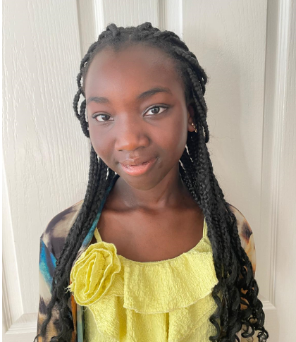

**Objective:** Aspiring young actor with a passion for performance and storytelling. Seeking opportunities to expand my experience in theatre and film.

**Experience:**

**School Plays:**

* **Moana** - Role: Te Fiti
  + Year: 2023
  + Responsibilities: Portrayed the benevolent goddess, contributing to the emotional depth of the story through expressive performance and collaboration with fellow cast members.

**Church Sunday School Plays:**

* **Unexpected Christmas**
  + Year: 2022
  + Responsibilities: Acted in a heartwarming holiday production, delivering lines with clarity and engaging the audience with a heartfelt portrayal of my character.

**Skills:**

* **Acting:** Strong ability to memorize and deliver lines, interpret characters, and express emotions effectively.
* **Teamwork:** Excellent collaboration skills, working well with cast and crew members to create cohesive performances.
* **Adaptability:** Quick to learn new roles and adjust to different performance styles and settings.
* **Communication:** Clear and confident in conveying messages to an audience, both verbally and through body language.

**Education:**

* **School:** Bullers Wood School for Girls, Bromley, Kent
  + Participated actively in drama club and school productions.

**Interests:**

* Theatre
* Storytelling
* Music
* Dance

**References:** Available upon request.

**Personal Statement:** I am Cherie-Ann Blay, an 11-year-old budding actor from Bromley, Kent. My experiences in school and church plays have ignited my passion for acting and performance. I am dedicated, enthusiastic, and eager to take on new challenges in the world of acting. Whether it's on stage or on screen, I am excited to bring characters to life and share stories with audiences everywhere.