**ROZHANA MURUGUPILLAI**

**Actor, Non Union**

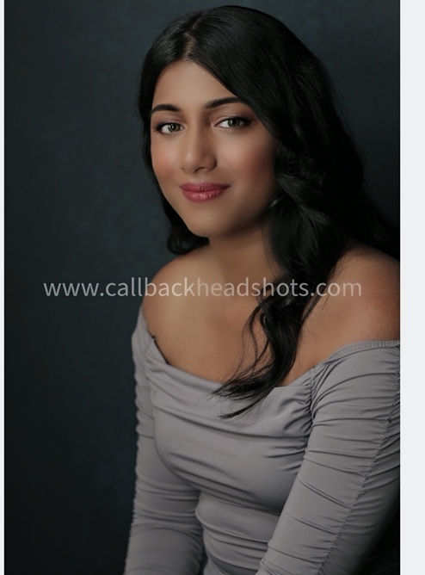

Cell Number: 647 819 0294

Email:rozhana_m@hotmail.com

**Measurements**

Location: Canada

Height:5F7 Weight:125pounds

Hair: Black

Eyes : Grey

____________________________________________________

**Training:**

**Alza** **Acting** **studio**( [**Address:**](https://www.google.ca/search?rlz=1C1AOHY_enCA710CA713&q=alza+acting+studio+address&stick=H4sIAAAAAAAAAOPgE-LWT9c3LMnLyjYzyNCSzU620s_JT04syczPgzOsElNSilKLiwHAy4nILgAAAA&sa=X&ved=0ahUKEwjF9-WJ--DTAhVF6YMKHdvkDAYQ6BMImAEwEQ)7 Hayden St #207s, Toronto, ON M4Y 2P2)

Scene Study, Cold reading, Audition Technique, Improvise, On Camera Class

**E** **fulcher** **Acting** **School**( [**Address:**](https://www.google.ca/search?rlz=1C1AOHY_enCA710CA713&q=fulcher+agency+address&stick=H4sIAAAAAAAAAOPgE-LWT9c3LEkvzyswLNOSzU620s_JT04syczPgzOsElNSilKLiwHyNz8jLgAAAA&sa=X&ved=0ahUKEwj8ytvv--DTAhVG0YMKHfE8CS0Q6BMIlAEwDw)340 King Street East, 2nd floor, Toronto, ON M5A 1K8

Performed Monologues, Cold reads, Improving, On Camera Class, Audition Technique,

Workshops **2013**- **2014**

**Evn Studios. (** Address: 2465 Dundas St. W, Toronto ON M6P1X3

Scene studies, Script Analysis, On Camera Auditions, and the realities of working in front of the camera

**__________________________________________________________________________**

**Education:** Harold M. Brathwaite Secondary School **2008**-**2013**

**Modeling:**

1. Miss India Worldwide Canada ( Miss Congeniality 2015)
2. Photographers portfolio – Krushit Vanzara

2024- Photographers portfolio- Dan

**Special** **Skills**:

**Languages**: English, Tamil  **Sports**: Baseball, Soccer, Badminton, Jogging, Biking, Football,