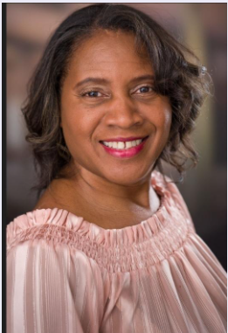 Milinda Jenkins

[Mjen1965@yahoo.com](mailto:Mjen1965@yahoo.com)

281-384-3483

Special Skills: Comedy, Drama, Sewing, Dancing

Additional Attributes:

Height: 5 ft 7 in., Weight: 175 lbs.

**Acting Credits**

The Lies We Are Taught Employee #2 Director Hildene James

Hood Fettish Leesha Davis Director Hildene James

Brothers Stage Play LeAnn Williams Writer/Director Annie Johnson

Unfinished Business Hope Gray Writer/Director Annie Johnson

She’s Got Papers Sis Branch Writer/Director Annie Johnson

What do we do now Edwana Johnson Writer/Director Kevo Aregbo

The Music Hotel Ms. Elaine Writer/Director Annie Johnson

Temptations Protestor Writer/Director Niecy Dobbins

The Doors of the Church Carmella Miller Writer/ Director Quincy Williams

Christmas Love Wars Shawn Carol Writer/Director Annie Johnson

Vincent Vincent’s mother Writer/Director Kevo Aregbo

Why I hate Church Folks Sister Eulla Writer/Director Dr. Angie Taylor

I am eager to learn and be a part of any productions in a small or extra role. Being able to bring a character to life is an awesome feeling. In 2023 I acted in 7 plays and look forward to many more. Bringing life to the character of the Writer is very fulfilling and a challenge to myself. Although I have had no formal training I believe in my abilities to bring forth the visions of the Writer and Director.