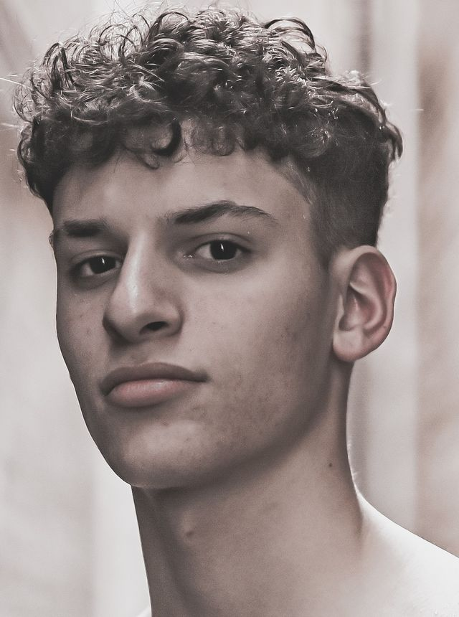Nathian Mercedes Rivera Non:union Contact:941-289-9388 Email:rivernathian@gmail.com Represented by: Manikin Talent Agency

Physical Attributes Height: 6ft Weight: 155lb Eye Color: Brown Hair Color: Brown Special Skills Skilled in freestyle dancing. Capable of adapting movement to various styles of music. Freestyle Dancing, Football, Basketball, Track. Training Face Forward Actors And Models Judi 2 Years Interest Proficient in various calisthenics techniques including bodyweight exercises. Knowledgeable about current fashion trends, styles, and designers. Comfortable with wardrobe selection, and styling. Skilled in freestyle dancing with a natural sense of rhythm, coordination, and improvisation. Capable of adapting movement to various styles of music and choreography.