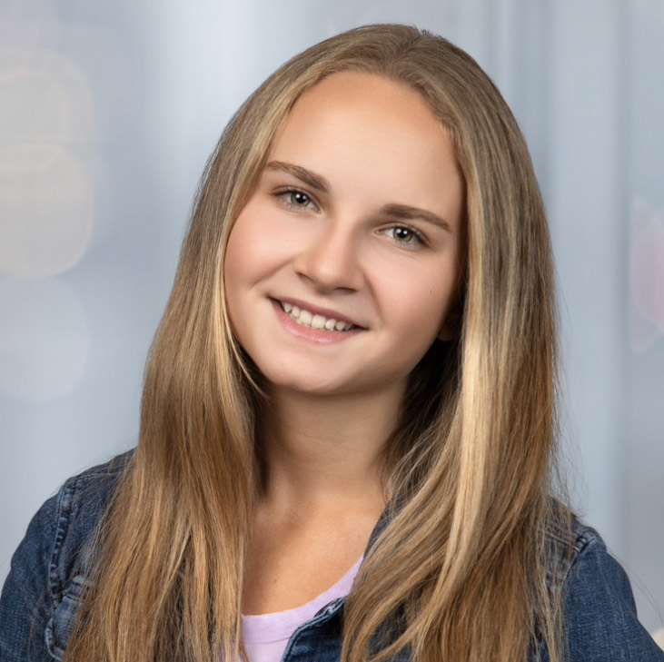 |  | Nadine elisabeth  Non-Union  Hair:Blonde Eyes:Hazel Height:5’3”
Profile  Nadine is a 16-year-old girl with a passion for performing. She has performed in many shows, the latest ones including “Beauty and the Beast” and “A Christmas Carol.” Not only does Nadine shine onstage, but also onscreen. She recently acted in an upcoming feature film, “City of Angels.” She has received extensive training in acting, singing, and dancing from highly experienced professionals. Looking younger than her age her whole life has been considered a blessing, and Nadine is looking forward to continuing achieving her goals.  Contact  EMAIL:  julie@donnabaldwin.com  WEBSITE:  https://nadineoceangirl.wixsite.com/mysite  skills  Acting  Singing  Dancing  Gymnastics  Art |  | Theatre Experience  Beauty and the Beast Jr. with Academy of Community Theatre (ACT II)  Silly Girl  13 shows at the Ent Center for the Arts in April 2024.  A Christmas Carol (Best of the Springs gold winner for Best Play)  Caroline, Martha Cratchit U/S  11 shows at the Ent Center in Colorado Springs in November 2023.  Film experience  City of Angels  Young Margo  Alleyway Boys Production Company (Brandon Swartz) Feature Film  Playground Heroes Sizzle Reel  Miranda  Alleyway Boys Production Company  Modeling experience  Fashion Republic Magazine  March and May 2024 editions  Lure Magazine  Child/Teen Edition, May 2024  training  Acting  -Teen Acting with Disney Channel star, Ronni Hawk  -Actor’s Workshop with Stephen Austin (Actor/Acting Coach, Yellowstone)  -Intensives/Classes with award-winning ACT and ACT II  Singing  -Vocal lessons with vocal coach, Chelsea Ronan  -Singing Youth of Denver (SYD) and Sweet Harmony (choir)  -Classes with Academy of Children’s Theatre (ACT) and ACT II  Dancing  -Dance Technique Classes (modern, jazz, ballet, hip-hop, tap)  -Ballet with the Sundance Studio  -Acro/Gymnastics with Cindy’s Dance Factory and Flipshack

