Samantha Lynn Scott, 20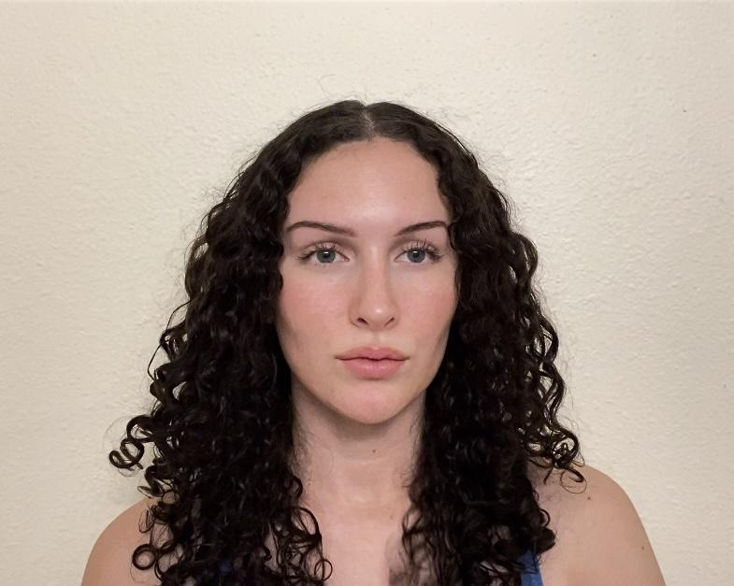

***Measurements***

*Shirt XS*

*Pant 2*

*Shoe 7*

*Breast 34C*

*Waist 24in*

*Hips 36in*

*Height 5’5*

*Brunette*

*Blue eyes*

***Experience***

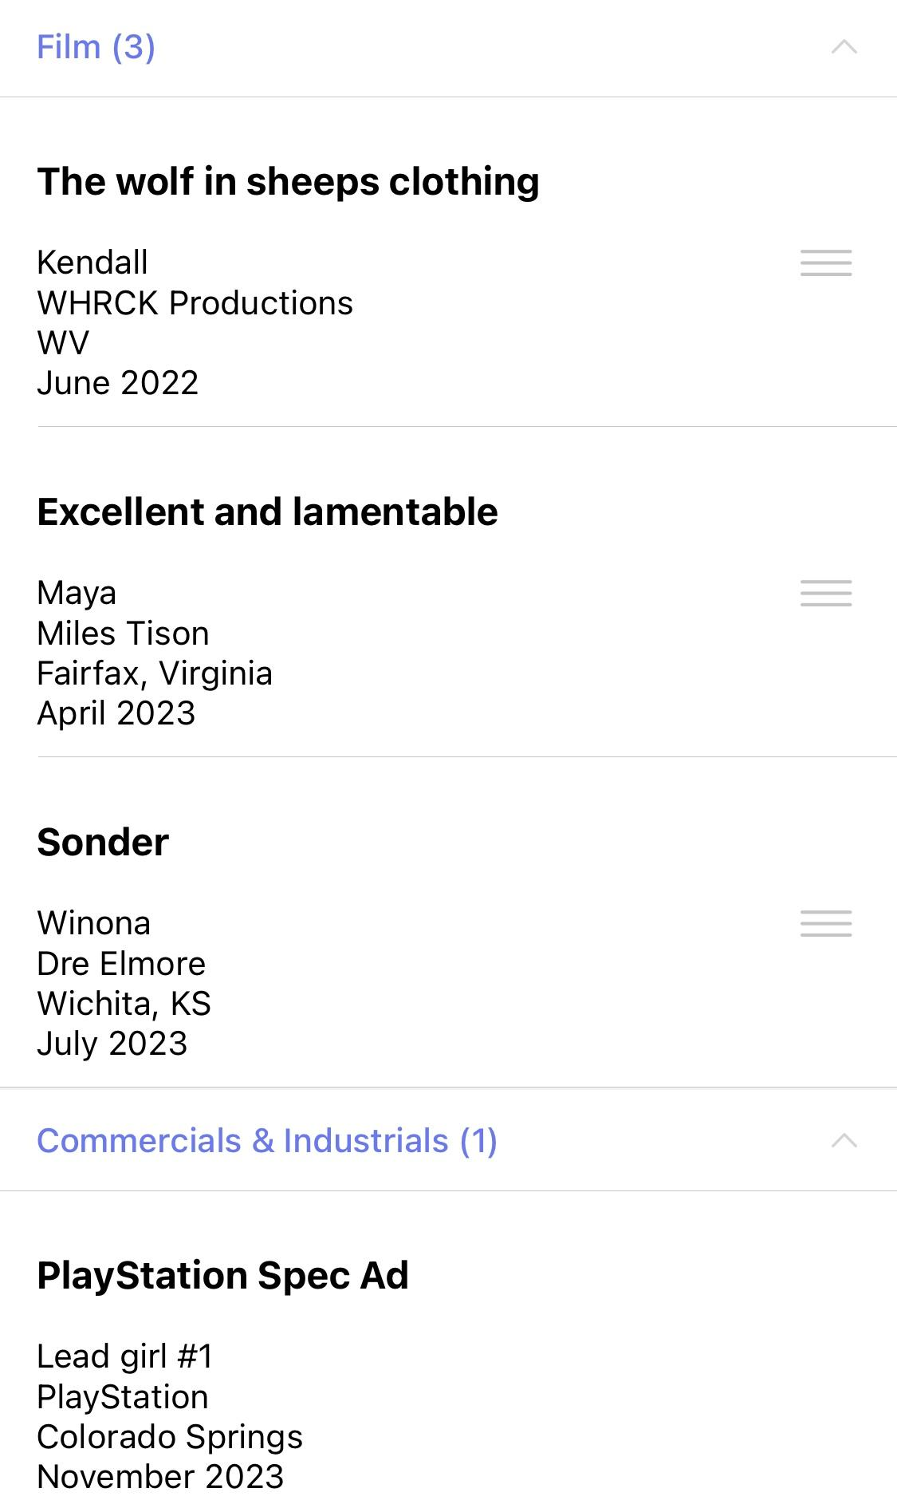

***Education in Acting***

*Acting Methods/Broadway Techniques 2019-2021*

*Barbizon 2017 (8 month course)*

*Pikes Peak State College Film Arts 2023-present*

***Links***

* [***Wolf in Sheeps Clothing***](https://youtu.be/tMM3KMXKKm4?si=3eWgGVtTjp8KuZxB)
* [***Excellet and Lamentable***](https://youtu.be/C5_17IlA3ls?si=8nmkW6Mwfqadd5vJ)
* [***Sonder***](https://youtu.be/vmtPReRfJ0s?feature=shared)
* ***PlayStation-Not yet out***