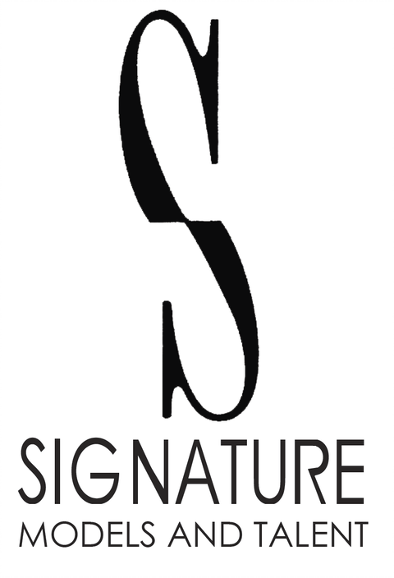
PMB #256 3370 N. Hayden Rd Ste. #123
Scottsdale, AZ 85251
Phone: 480-966-1102
Fax: 480-223-6444
mailbox@signaturemodelsandtalent.com

J Pantoja

Height: 5’10” | Weight: 185 lbs | Hair: Brown | Eyes: Brown

FEATURE FILM

Operation H.O.P.E Supporting Dir. Phillip Penza

COMMERCIALS

Town of Tusayan Featured MyCreative Inc
Lectric Bikes Principal Dir. Matthew Goennier
OneAZ Credit Union Principal OneAZ Credit Union
RPM Living Featured Dir. Cameron Hull
Parker & Sons Principal Moneta De Sine
Arizona State Fair Featured MyCreative Inc
TruWest Credit Union Principal MyCreative Inc

FILM

Noir En Gris Lead Dir. Drake Burnett
BEBO Was Here! Supporting Dir. Freddy Sauceda
Gloria Lead Dir. Jeremy Baker
Technicolor Dreamboat Supporting Dir. Emilie Grimes
Obsidian Lead Dir. Caleb Baker
It’s All About Tuesday! Supporting Lead Dir. CJ Metz
Quirk Supporting Dir. Emilie Grimes
Going Postal: The Legacy Foretold Supporting Dir. Tad Sallee & Jason Sikorsky
Church! Supporting Dir. Cale Jayden

MEDIA

Work Supporting Lead Dir. Luke Wynn

TRAINING

Improv for Actors Jacque Arend Arizona Actors Academy
Acting for TV/Film Randy Messersmith Arizona Actors Academy
Acting Foundations Rachel Grimes Arizona Actors Academy

SPECIAL SKILLS

Baseball, Running, Football, Basketball, Softball, Cooking, Weightlifting, Bodybuilding, Video Games

