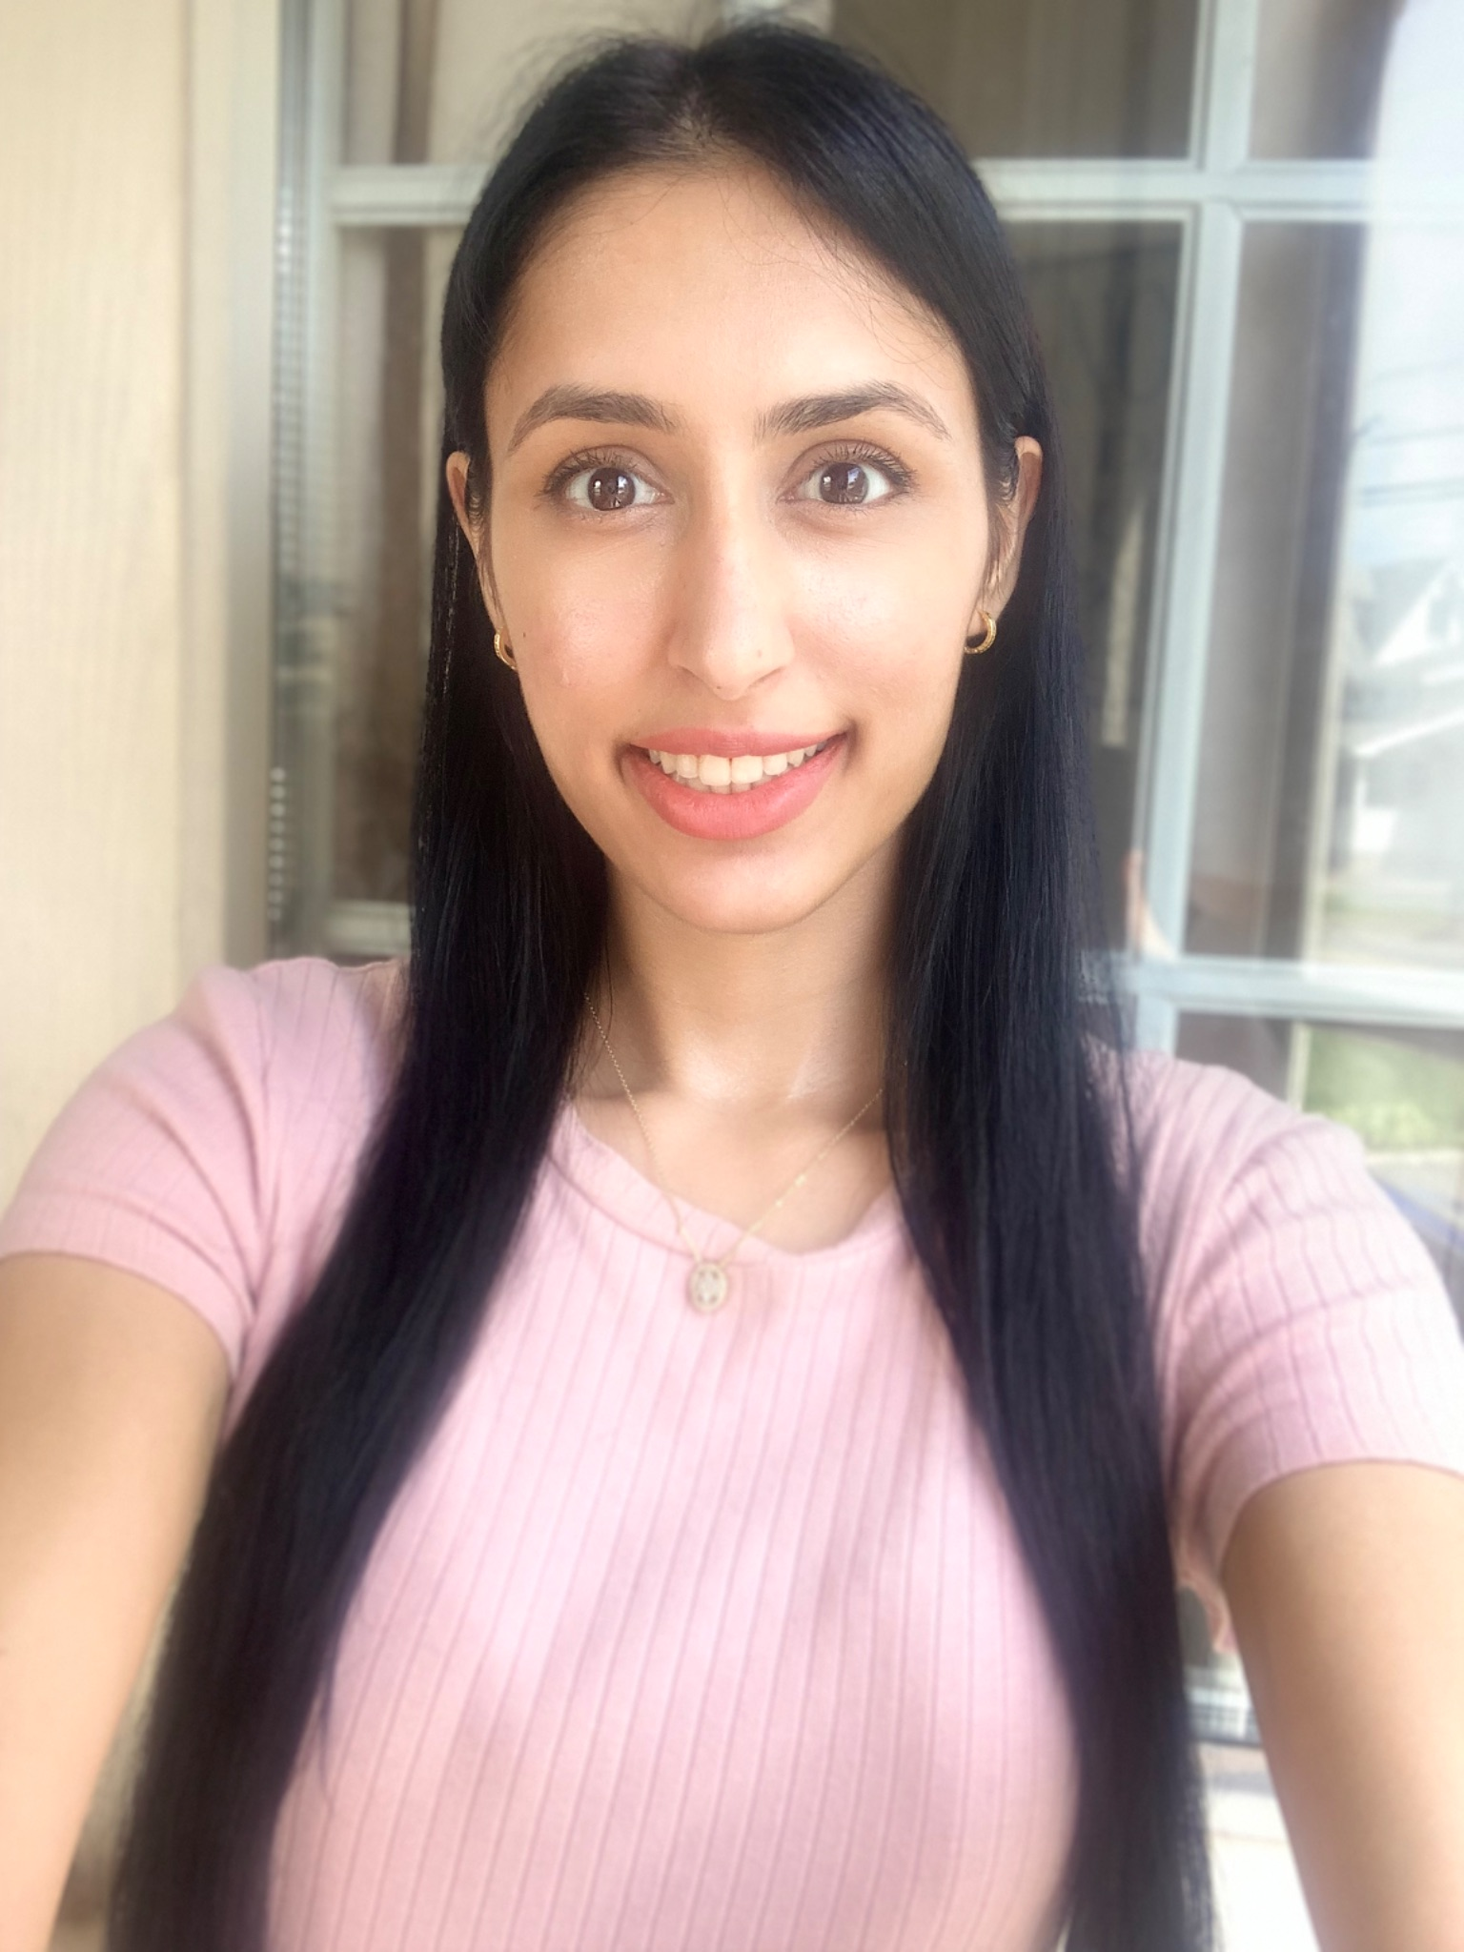

Harsha Mirchandani

New Jersey

Cell: 973-908-0305

Dear Human Resources,

I graduated with a bachelor's degree from Rutgers University. I appreciate your time in reading my cover letter and resume.

My degree at Rutgers is Public and Non-Profit Organization. I am still learning, as I am passionate about further studies and I would love to complete an MBA. I love international business/relations and community engagement as we are a team together for the message of love and unity.

I have trained in rhythmic gymnastics for a recreational coach and I love children! I have taught flexibility classes in college for a dance studio and I’ve worked in daycare at a fitness studio. I have been part of dance teams for 15 years on and off in high school and college. The creative art forms are a passion!

I believe everyone has inner beauty within themselves and I would love to make them feel beautiful with self-love. I have auditioned for modeling, modeled for beauty services and have experience in with studio equipment for modeling pictures. We all have potential, we all deserve to treat ourselves, and I would love to show women to embrace their inner beauty. I believe we can all be ourselves and each person would feel an inner happiness as we can see an individual’s smile. Multicultural beauty is to appreciate every ethnicity. Each race and ethnicity is beautiful inside and out. I started my passion of creating a beauty brand and helping in sustainable business. I have experience in content creation, photography and video on instagram for a previous fitness page, which turned into the arts. I have experience creating visual content for a website as well. I have brand ambassador, community engagement experience and event marketing experience with Nobody Denied Training Zone.

I interned at the United Nations Global Compact. I am passionate about the 2030 Development Goals. As part of being an intern at the organization, I was fortunate to assist in the restructuring in the business strategy with the team and programme portfolio. I was able to learn about teamwork, the action platforms, the SDGs, for example the Reduced Inequalities, and assist with their events in Manhattan, as they had events in India. I provided assistance with webinars and attended team meetings by taking notes. I believe that everyone has a chance to find a home in their workplace, as people grow together. I believe it can bring people confidence in their lives and it can create a balance in their studies. I love events and organizing! It’s a lot of fun to create and bring a smile to people’s lives.

I am passionate about the arts, such as singing, dancing, and languages as well! I have experience recording a song at a music studio with the recording equipment. The arts bring a smile and enriches the lives of others! I have been working on a grant proposal last summer for my nonprofit Tasteful Arts; as it includes the performing arts, forms of other artistic creativity, beauty. I believe children are valuable to learn from. As they grow, it’s important to be warm to their development. I have worked with children in my previous work experience at Huntington Learning Center along with daycare; and, I would love to help the underprivileged youth and their families with the Tasteful Arts nonprofit.

I have some experience with the grant application process. The grant application process is included in my experience working with the Department Chair and Program Manager at Rutgers University at their Health Sciences building, assisting with the grants, and I have assisted Morris Arts Organization with grants as well. I have also worked at Rutgers University at their Health Sciences department during covid. I am able to assist with the grants, communications, logistics and administrative duties.

Furthermore, I am able to assist with the concerts on Saturdays as needed. I have word, excel and PowerPoint experience. The reason there is a gap in my resume is because last year I have been traveling on a gratitude journey to see family to a couple of places in Mumbai, India and Toronto, Canada. I appreciate the time and consideration that you have put into creating the opportunity for this work. I would be excited to be part of your team and learn more!

Thank you so much for reading my cover letter and resume; and, I would love to hear from you soon!

**HARSHA MIRCHANDANI**

(973) 908-0305 h.mirch7@gmail.com

SKILLS

* Proficient in Microsoft Office, PowerPoint, Excel, Google Docs, Gmail and Salesforce. Familiar with Gliffy, Cyberduck, and Slack.
* Google Project Management: Professional Certificate (October 2021 – Present In-Progress).
* Certifications in United Nations Internship Program (Feb 2017 – July 2017), Women Entrepreneurship NYC Leadership & Business Workshops (Feb – May 2018), Certifications in United Nations Internship Program (Feb 2017 – July 2017), United Way Leadership Mentor Training (Mar 2013), CPR & First Aid.

EDUCATION

* Rutgers University, Newark, NJ October 2016   
  *B.A, Public and Non-Profit Administration*
* Social Club House Program Pre-Vocational and Classes November 2023 - Present

EXPERIENCE

**Angelie Amaria**, New Jersey June 2024 - Present  
*President and Co-Founder of Beauty Brand*

* Researched material in June 2023 to help the underprivileged communities for the arts and culture. I have edited it to be a beauty brand separate from a nonprofit entity this year in 2024.
* Mentors as guidance to start the brand with partnerships and team. It is a brand to show we are together as a team in the creation of the beauty brand.
* I have created the presentation and business proposal in process.
* I have contacted manufacturers to inquire about products.

**Freedom Dance Academy**, Manhattan, New York August 2024  
*Recreational Rhythmic Gymnastics Coach Training*

* Assisted in teaching young girls rhythmic gymnastics, flexibility and dance.
* Assisted the manager in ballet techniques and exercises to prepare for the choreography.
* Assisted in the development of young girls to build confidence and encourage teamwork.
* Cleanliness of the studio is important. Maintained a clean area for the students.

**United Church Funds**, Manhattan, New York June 2022 - December 2022  
*Administrative Assistant*

* Assisting the Finance Manager, attending meetings with the team, providing administrative support, and answering emails,
* Utilizing CRM System to keep track of donors to their churches, assisting with financial transactions, & calendar management.
* Utilizing Innovest Systems - a wealth management software for financial.
* Maintaining a clean office, watering plants, and keeping a fun atmosphere.

**Next Generation Trust – Financial Services**, Roseland, NJ October 2021 – November 2021

*Temp Contract Role - Account Representative Administrator*

* Assisting the Director of Finance and Transaction Managers. Providing administrative support as part of the Transactions team, answering emails, keeping a clean office, maintaining employee and customer records.
* Utilizing Salesforce CRM System to store customer information, calendar management, take notes & generate forms.
* Utilizing Innovest Systems - a wealth management software for self-directed IRAs Individual Retirement Accounts.
* Utilizing Excel to store financial data and sorting mail. Utilizing Microsoft Office Suite. Organizing digital files of financial information and data entry.
* Facilitate the incoming and outgoing process of forms. Mailing out invoices, statements, providing customer service to phone inquiries and utilizing the scanner/fax and printer. Answering questions and finding information for employees, vendors and clients. Keeping track of supplies, inventory and staff calendar.

**Rutgers University**, Newark, NJ March 2020 – June 2020

*Administrative Assistant to the Executive Chair*

* Assist with departmental projects, update the projects and collect data utilizing Microsoft Office.
* Correspond to emails with professors, senior officials, department’s staff, program administrator and Chair.
* Assist with scheduling meetings, create meeting minutes and collect mail.
* Process staff related documents, such as timesheets, requests for leave and personal evaluations.
* Assist with financial budgeting activities utilizing excel.
* Assist with grants utilizing Rutgers RAPSS software and prepare agendas. Assisting with the grant proposal process and maintaining confidential files.

**Huntington Learning Center**, Morristown, NJ June 2018 – November 2018

*Assistant to Director*

* Oversee the operations and marketing functions of the organization while reporting to the Director. Assist with financial activities, reports, developing, reviewing and mailing statements, collecting and depositing payments, managing returned checks and refunds, collecting overdue tuition and fees, preparing for daily maintenance meetings, assisting in daily revenue goals, maintaining documents, and general organization.
* Perform payroll functions, including maintenance of daily time sheets, calculation of payroll hours, and submission of payroll to the Center Director for approval. Monitor, program, and reprogram student instructional programs. Monitor and prioritize various forms of communications, including email from various clients, officials & corporate offices.
* Responsible for assisting with the hiring process, training, scheduling and supervising teachers; conducting monthly teacher meetings. Create external partnerships and marketing with various businesses to help grow the company.
* Perform administrative activities: Answer phones, maintain appointment book, input data, file, mail material, and maintain answering machine. Maintain inventory; submit list of needed items to Center Director for approval and processing. Maintain Center appearance, including waiting room, offices, instruction areas, bathroom, as well as the halls and other spaces outside the Center. Create and maintain student and teacher schedules.

**Diversity Organization**, New York, NY January 2016 – March 2018

*Executive Administrative Assistant*

* Reported to the CEO during its startup stage for various administrative and organizational support with imperative deadlines. Supported officials, scheduled meetings, created reports.
* Maintained confidential files, prepared background material for meetings, proofread & edited documents and modified proposals for sales development. Utilized Microsoft Suite & Google Docs.
* Conducted high-level research – developed donor list of Fortune 500 Sponsors, grant research, list of high schools with contacts of Senior Officials to educate on social causes, contacted Officials via phone in regards to setting up sales meetings.
* Built relationships with all levels of staff & contributed feedback for the development of the organization. Constantly learning with Leadership, Communication & Public Speaking Training Workshops.
* Public Speaker – content development & storytelling, collaborated with team in trainings, engaged with audience, spoke in front of 500+ of students at high schools to educate youth on social causes, equality & diversity.
* On-Stage Camera Personality with YouTube Partnership to promote diversity & positive social change.

**United Nations Global Compact**, New York, NY February 2017 – July 2017

*Program Contract Internship*

* Assisted in managing the Chief of Programmes day-to-day agenda; prepared background materials and internal communications
* Provided research capacity for speakers briefing notes, attended international webinars, monitored project progress and outcomes, prepared PowerPoint presentations, and good practice meeting notes;
* Supported the development of the new Climate Action Platform Program Management and Science Based Target- Initiative.
* Facilitated Global Compact’s outreach and events, such as the Making Global Goals Local Business in India (26- 27 April 2017); the Women Empowerment Principles Annual Event (14-15 March 2017).
* Assisted in restructuring of the business strategy and program portfolio with particular focus on the quantitative data, engagement and communication with internal and external multi-stakeholders, businesses, governments and civil society – 9,670 international and local business partnerships in 163 countries; Assisted in the development of the Global Opportunity Explorer – a joint partnership with Sustainia and DNV
* Compiled market research on sustainability trends analysis and corporate sustainability; developed content and design for new Lead Lab Hub Site and updated the UNGC web database.

**Morris Arts Organization**, Morristown, NJ September 2015 – December 2015

*Internship*

* Assisted with events at Morris Arts, such as Pumpkin Illumination and Meet Me in Morristown.
* Assisted with the grant applications, as they provide grants to local organizations and learned about the process that organizations apply for grants.
* Worked with staff to develop the outreach materials to maintain a list of artists, musicians, performers, and assisted with sending thank you cards.
* Assisted with administrative duties as needed and interacted with all levels of staff.

**New Web Design**, Morristown, NJ January 2015 – July 2015

*Executive Assistant and Project Management Associate*

* Managed the Chief Executive Officer’s day to day agenda, invoices, scheduling meeting logistics, being the point of contact for the office, attending external client meetings with CEO, meeting minutes, creating sales team instructions, rebuttals, price list, information packets, content for client websites, press releases, testimonials, proposals/contracts, social media, SEO, wireframes for apps and page layouts.
* Worked with CEO to build the business in multiple areas, managing various projects to accomplish the work within the given deadlines, nurturing relationships with employees of all levels. In charge of the project management cycle, delegated tasks to multiple teams to ensure projects were executed efficiently.
* Examined and analyzed project specifications with clientele, discussed business services, attended weekly meetings to ensure project details were accurate to provide the best work. Organized projects utilizing Excel and Microsoft office.

**Nobody Denied Training Zone**, Morristown, NJ June 2014 – December 2015

*Administrative, Marketing and Project Coordinator Associate*

* + Worked with Sales Executive Director on various projects and with administrative duties. Planned and monitored the progress of the projects, meeting with clientele to ensure efficient outcomes.
  + Built and maintained strong relationships with clientele and senior level officials. Managed clientele data in the Club Ready CRM system. Generated $218,500 for the company with the Director.
  + Started out as a brand ambassador for the company. Then developed strategic partnerships with organizations, researched marketing opportunities, utilized grassroots strategies, experiential and event marketing & identified venues to collaborate in events such as 5k marathons, fundraising parties, business cross promotions, and charities. Managed events with 500-2,000 attendees.
  + Recruited and managed personnel on promotional team from college students to young professionals, led business projects & events, educated team on products, communicating details to leverage project leads/sales.

**Town of Morristown Government**, Morristown, NJ January 2014 – December 2014

*Administrative Assistant*

* Supported senior officials in various divisions as administrative assistant, to facilitate plan implementation & execution. Analyzed Morristown’s programs, goals, strategies & activities. Assisted with projects, organized confidential files, utilized Microsoft Office & Excel. Developed safety brochures for residents regarding preparedness for unexpected disasters.