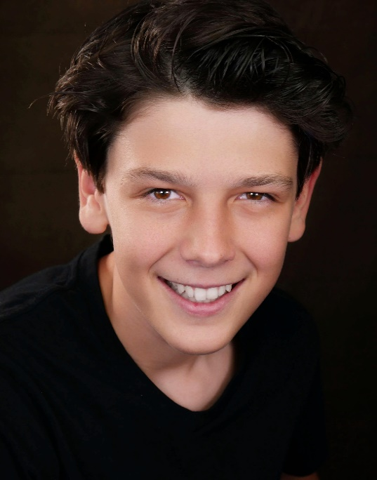

Nuanced and adaptable young actor with developed memorisation abilities seeking commercial or film work.

**deasther6@gmail.com**

Height: 168cm

Weight: 60kg

Eye colour: Brown

Date of birth: 20/10/2007

Ethnicity: Australian, Italian

**0498 123 595**

**Education/Training**

* Myles Pollard – Acting for Camera Workshops
* Ali Roberts studio – Screen Youth Acting
* Artist Management Australia – Acting Bootcamp
* AMEB – Speech and drama
* ATAR – Drama
* Barking Gecko – Junior Ensemble

**Special Skills:**

* Karate Black Belt (State rep)
* Weapon artist
* Piano
* Video editing
* Running
* WAFL Umpire (AFL umpire)
* Kayaking
* Bike riding

**Experience**

Credits:

* Runt – Extra and featured scene

Television:

* Telethon Panel
* Commercial Voice overs
* Channel 7 News articles

Podcast:

* KidsQ’s podcast host (The West Australian)

Theatre:

* A Streetcar named Desire
* When a Rain Stops Falling
* Poetry Eisteddfod
* Wesley Takes the stage