Angel Strong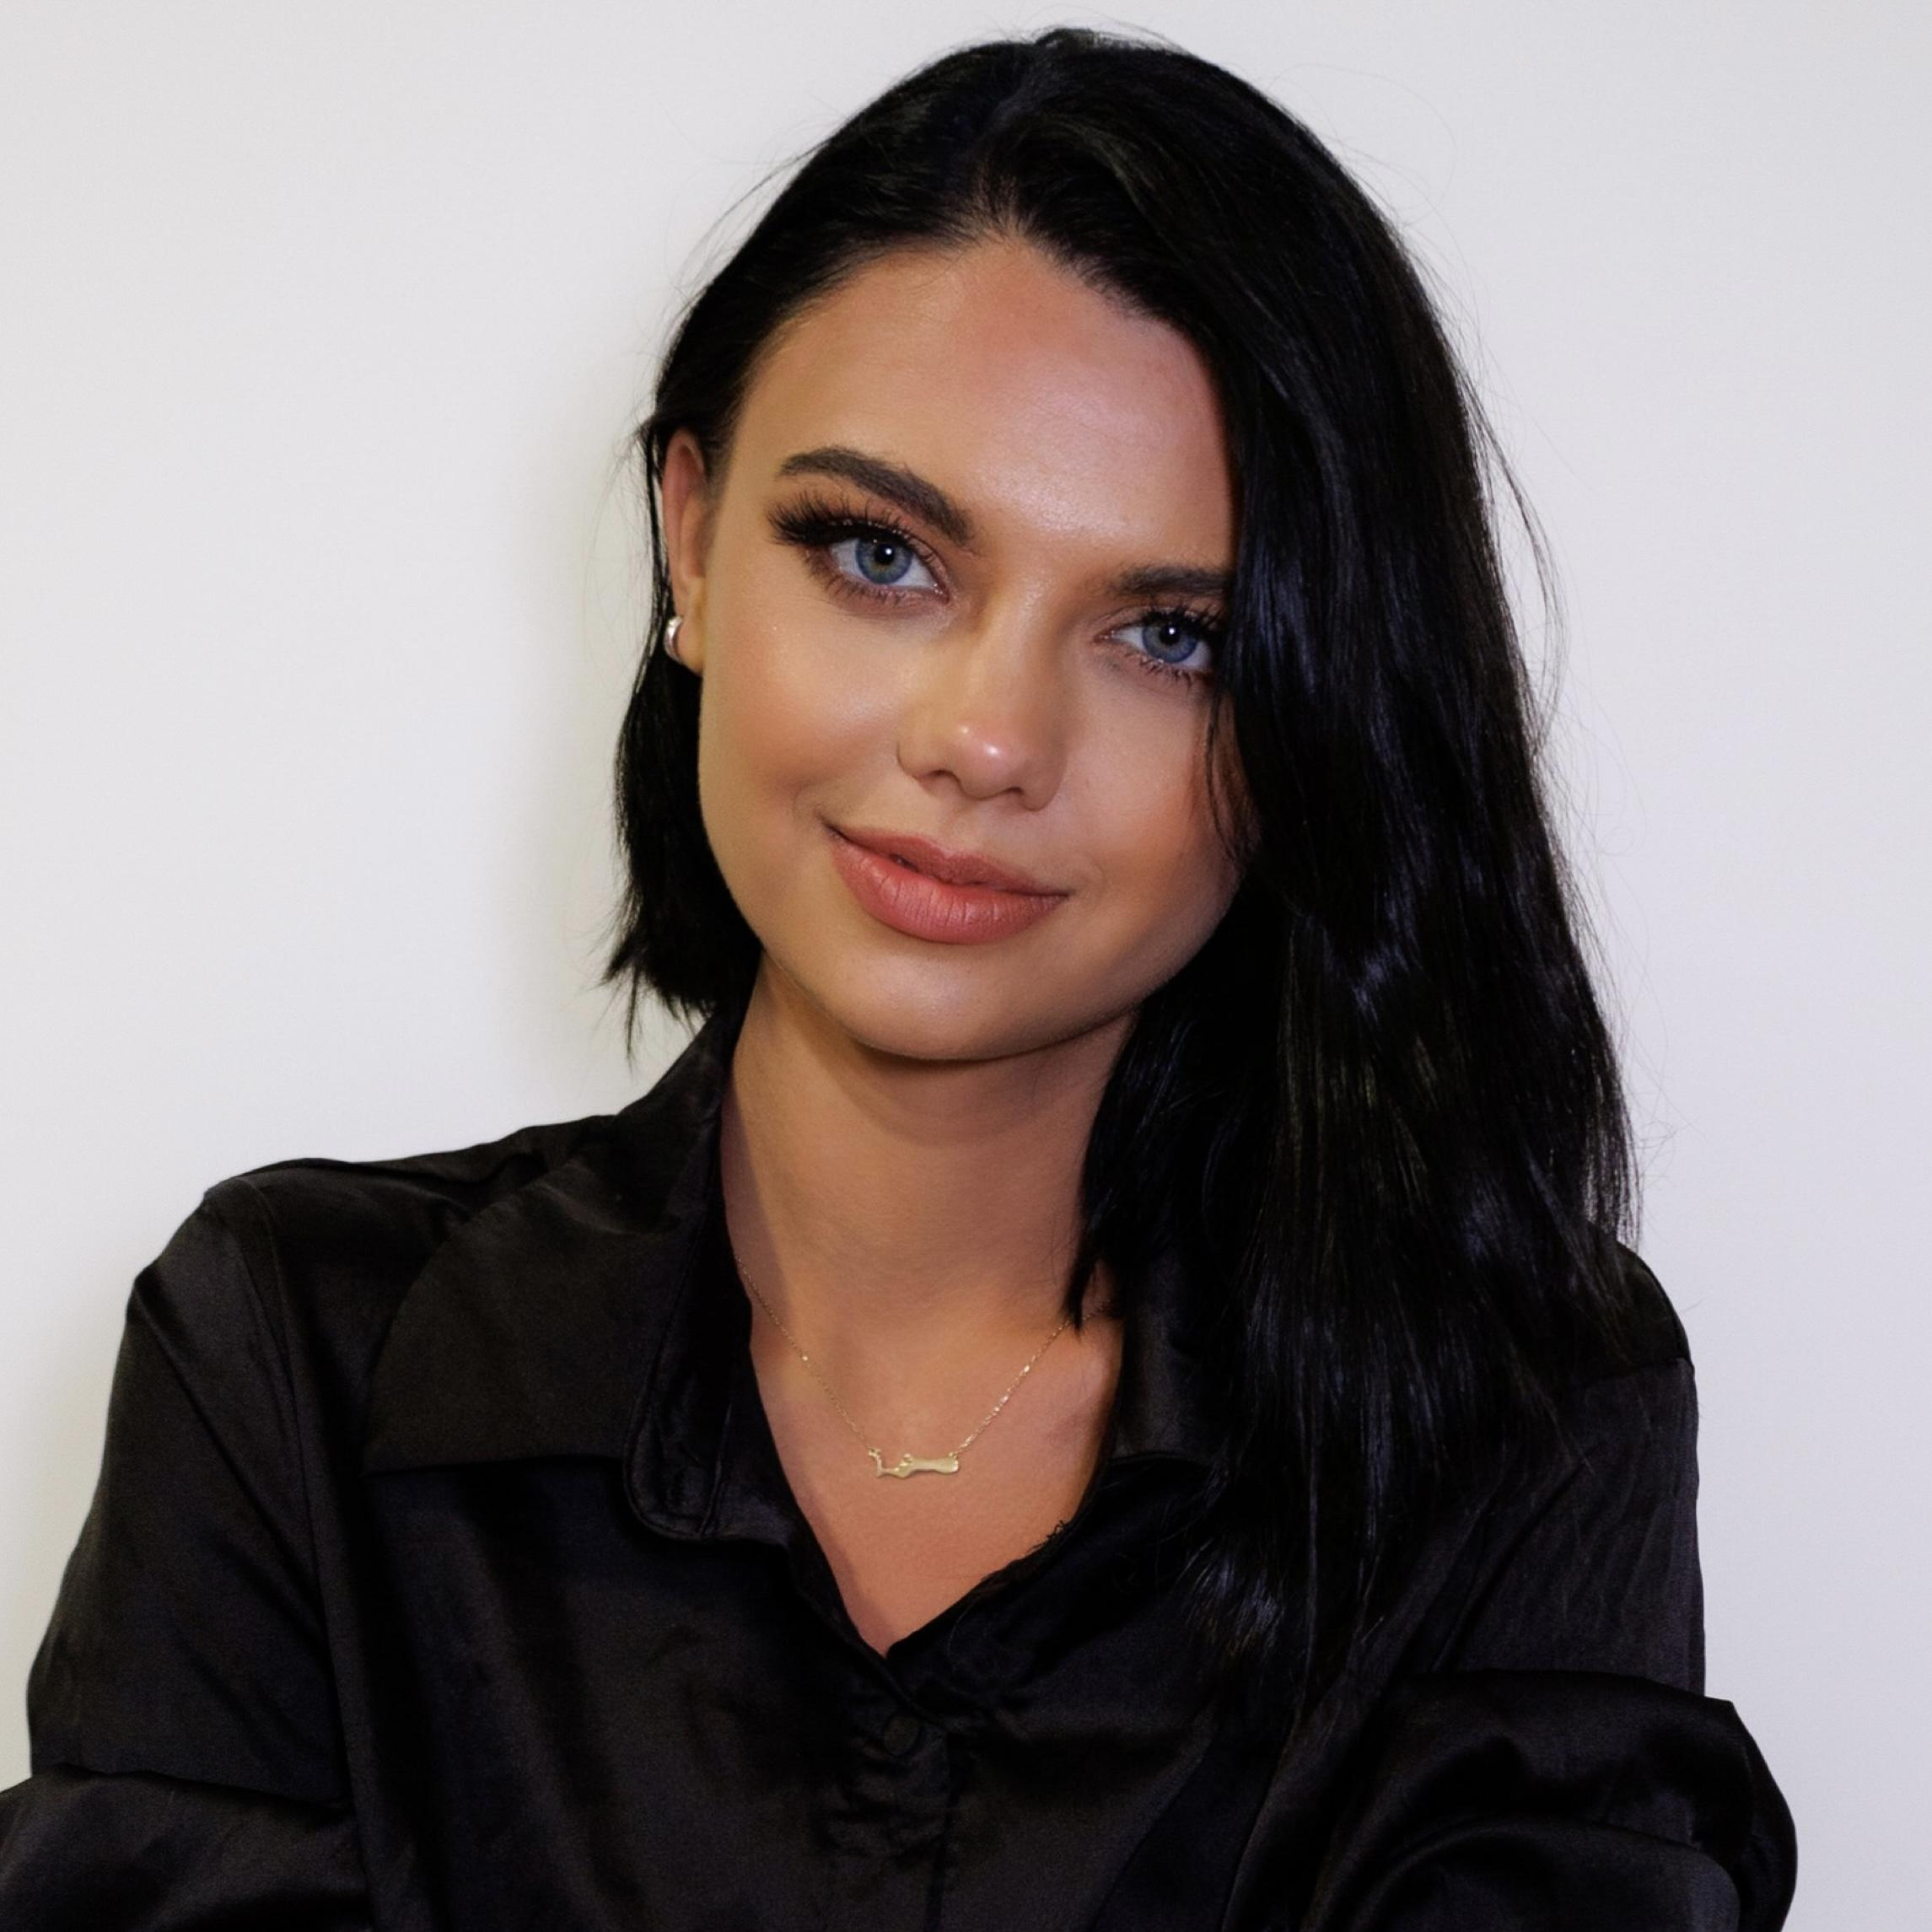

(Non-Union)

402-450-5811

strong.angel312@gmail.com

Height: 5’ 9” (175 cm)

Weight: 105 lbs (47.6 kg)

Eye Color: Green

Hair Color: Black

____________________________________________________________________________________

**THEATER**

*The Odyssey* Princess Nausicaa Lincoln Community Playhouse ‘20

____________________________________________________________________________________

**FILM/TV**

*Miss Malice* Lead Dylan Haratoonian ‘24

*Lovewaves* Co-Star DirectorName ‘23

____________________________________________________________________________________

**MODELING/COMMERCIALS**

*New York Fashion Week* Runway Model ZCrave‘24

*Orlando Surf Expo* Showroom Model Heat Swimwear ‘24

*Atlanta Formals Market* Showroom Model Nicole Bakti ‘24

*Miami Swim Week* Runway Model Planet Fashion TV ‘24

*Website and Ecommerce Shoot* Print Model Humans the Brand ‘24

*Website and Ecommerce Shoot* Print Model Caya Sportswear ‘24

*Website and Ecommerce Shoot* Print Model Pink Apple Dresses ‘24

*Website and Ecommerce Shoot* Print Model The Ladycode Shop ‘23

*Website and Ecommerce Shoot* Print Model Vizcaya Swimwear ‘23

*Commercial* Lead Miss Earth USA ‘23

*Commercial* Lead The Ladycode Shop ‘23

*Commercial* Lead Vizcaya Swimwear ‘23

*Atlanta Formals Market* Showroom Model Colors Dresses ‘23

__________________________________________________________________________________

**SPECIAL SKILLS**

Dialect (Southern American, British, Irish), Conversational French, Stage Falling/Stunts