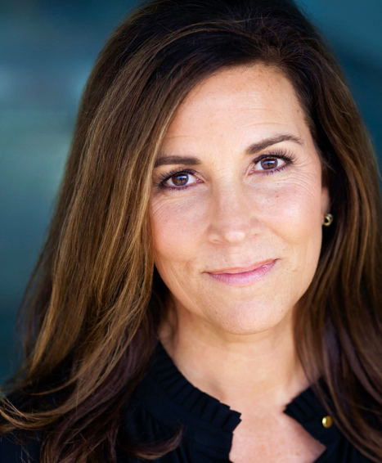

**PATTY LAMBERT**

pglambert5@gmail.com

704-756-5864

Height: 5’ 8” / Build: Slim

**FEATURE FILM**

Farm to Fork to Love (Amazon Prime) Lead Director. Sandra L. Martin

My Sweet Holiday (Lifetime TV) Supporting Lead Director, Sandra L. Martin

Rebuilding A Dream Christmas (Lifetime TV) Supporting Director, Sandra L. Martin

No Vacancy Supporting Director, Kyle Saylors

The Skeleton’s Compass (Apple TV) Supporting Lead Director, Sandra L. Martin

Caged Supporting Director, Michael A. Walker

Momma Bird (post-production) Supporting Director, Bradley Stryker

Amazing Gracie (post-production) Supporting Lead Director, Micah Caronna

**COMMERCIAL**

RMCA Brand Story

Carolinas Center for Cosmetic Surgery

Bardi Heating and Air

Zero Odor

**EDUCATION & TRAINING**

B.A., Speech Communications UNC-Chapel Hill Honors Cum Laude

~ Oral Interpretation of Literature ~ Order of the Grail-Valkyries

Film Acting Class (Ongoing) Film Actors’ Studio Lon Bumgarner

Voiceover & Business (Ongoing) Private Coaching Gabrielle Nistico

Scene Study Virtual Alyschia Ochse

Coaching Session Virtual Erica Bream

Elevate (Business of Acting) Virtual Arvold Warner Studios

**LINKS & REELS**

IMDb: [imdb.me/pattylambert](https://www.imdb.me/pattylambert)

Actors Access: <https://resumes.actorsaccess.com/pattylambert>

Instagram: <https://www.instagram.com/lambert.patty/?hl=en>

YouTube: <https://www.youtube.com/channel/UCQmRbZ9bMrBlNEJ-sCyr2RQ>

2022 Demo: <https://youtu.be/SQaN2ibZ1dw>

**SPECIAL SKILLS**

Southern American Accents (refined and rural) • Aerobics • Tennis • Billiards • Cooking • Stage Acting •

Cycling • Pilates • Golf • Mothering • Wife-ing • Public Speaking • Event Planning • Fund-Raising •

Dancing With the Stars (for charity) • Bad Karaoke • Potent Drink Maker

**OTHER INTERESTS**

As a high-energy individual, I feel passionate about many things: food, drink, faith, equality, perseverance, bettering the world, and working hard for what I want. A passion near and dear to my heart is integrating quality arts education into the formative years of a child’s life. I have witnessed the transformation and a sense of purpose in others from the power of creative and innovative thinking and seen children from all walks of life, including my own, given a new route to success and higher education through their experience with the Arts. My enthusiasm for outstanding and accessible arts education for ALL remains a core value today.