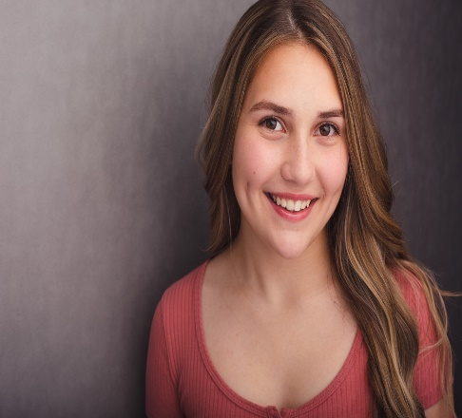
Macy James Magas

239-851-7373 Height: 5’2”
Email: vcrews14@aol.com Weight: 140 lbs (63.5 kg)
Eye Color: Brown
Hair Color: Brown
Vocal Range: G3 – C6
___________________________________________________________________
Theatre
Mary Poppins Ensemble Broadway Palm Dinner Theatre ‘24
The Music Man Zaneeta Gulf Coast Symphony ‘24
Nunsense II Mary Amnesia u/s Gulf Coast Symphony ‘24
Mary Leo u/s
Mean Girls Cady Heron Canterbury School ‘24
The Little Mermaid Ensemble Broadway Palm Dinner Theatre ‘23
SpongeBob the Musical Sandy Canterbury School ‘23
Elf the Musical Deb Canterbury School ‘23
Little Women Beth March Ft. Myers Theatre ‘23
Wizard of Oz Ensemble Broadway Palm Dinner Theatre
The Sound of Music Louisa Broadway Palm Dinner Theatre
The Music Man Ensemble Gulf Coast Symphony
Annie July Broadway Palm Dinner Theatre
A Christmas Story Susan Broadway Palm Dinner Theatre
Chicago Teen Edition June/Roxie u/s,perf The Belle Theatre
Newsies Race The Belle Theatre
Wizard of Oz Lion Canterbury School
Lord of the Flies Piggy Florida Repertory Education
Bulletproof Backpack (World Premier) Andrea Florida Repertory Education
Godspell Jr. Jesus Florida Repertory Education
Newsies Ensemble Florida Repertory Education
___________________________________________________________________
Commercial
Gaylord Palms Resort & Convention Center Escape Visuals
___________________________________________________________________
Training
Acting – Kody C Jones, Aaron Jackson
Dance – Sami Doherty, Amy McCleary
(Tap, Ballet, Pointe, Jazz, Lyrical, Hip-Hop, Contortion)
Piano – Rosalind Metcalf
Vocal – Rosalind Metcalf, Amy McCleary
___________________________________________________________________
Theater Awards and Recognition
Lee County High School Music Awards (2023) – Deb in Elf, Canterbury High School Outstanding Principal Performer
BWW Winner for Best Performer in a Musical (2021) – Godspell Jr, Florida Repertory Education
BWW Winner for Best Supporting Performer in a Musical (2021) – Into the Woods Jr, Florida Repertory Education
BWW Winner Best Supporting Performer in a Play (2021) – Bulletproof Backpack, Florida Repertory Education
BWW Winner for Best Non-Professional Actress (2019) – Marlin in Finding Nemo Jr, Melody Lane PAC

