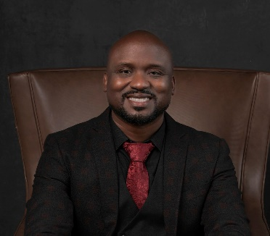 | Law  - Rolle  Actor & Model
CONTACT  Orlando, FL  407-494-6369  drknyht@gmail.com  www.instagram.com/rolle.models  Personal Details  Height: 5’11.5”  Weight: 190 lbs.  Build: Average  Hair: Shaved  Eyes: Brown  Role Ages: 30-50  Expertise  Speaking Roles  Monologues  Modeling  Stand-In  Background  Intensity  Comedic | Online content  Disney – AP Father’s Day – Principal – 2024*  Disney – Tiana’s Bayou – Background – 2024  Disney – Disney Wish – Background – 2024  SeaWorld – Penguin Trek – Background – 2024  Disney – Jollywood Nights – Background - 2023  Holiday Inn Vacation Club – Background - 2023  Television  NBC/Universal – Jimmy Fallon 10yr – Background – 2024  Stand-In  Tide Commercial – Stand in for Noah Lyles – 2024  Olympics – Stand in for Noah Lyles - 2023  THEATER  Communion to Calvary – Judas Iscariot - 2024

*speaking role

