Karen Menin  25512 Fountain Glen Court #303  Stevenson Ranch  CA 91381  858-265-2762  ckmenin@pacbell.net | 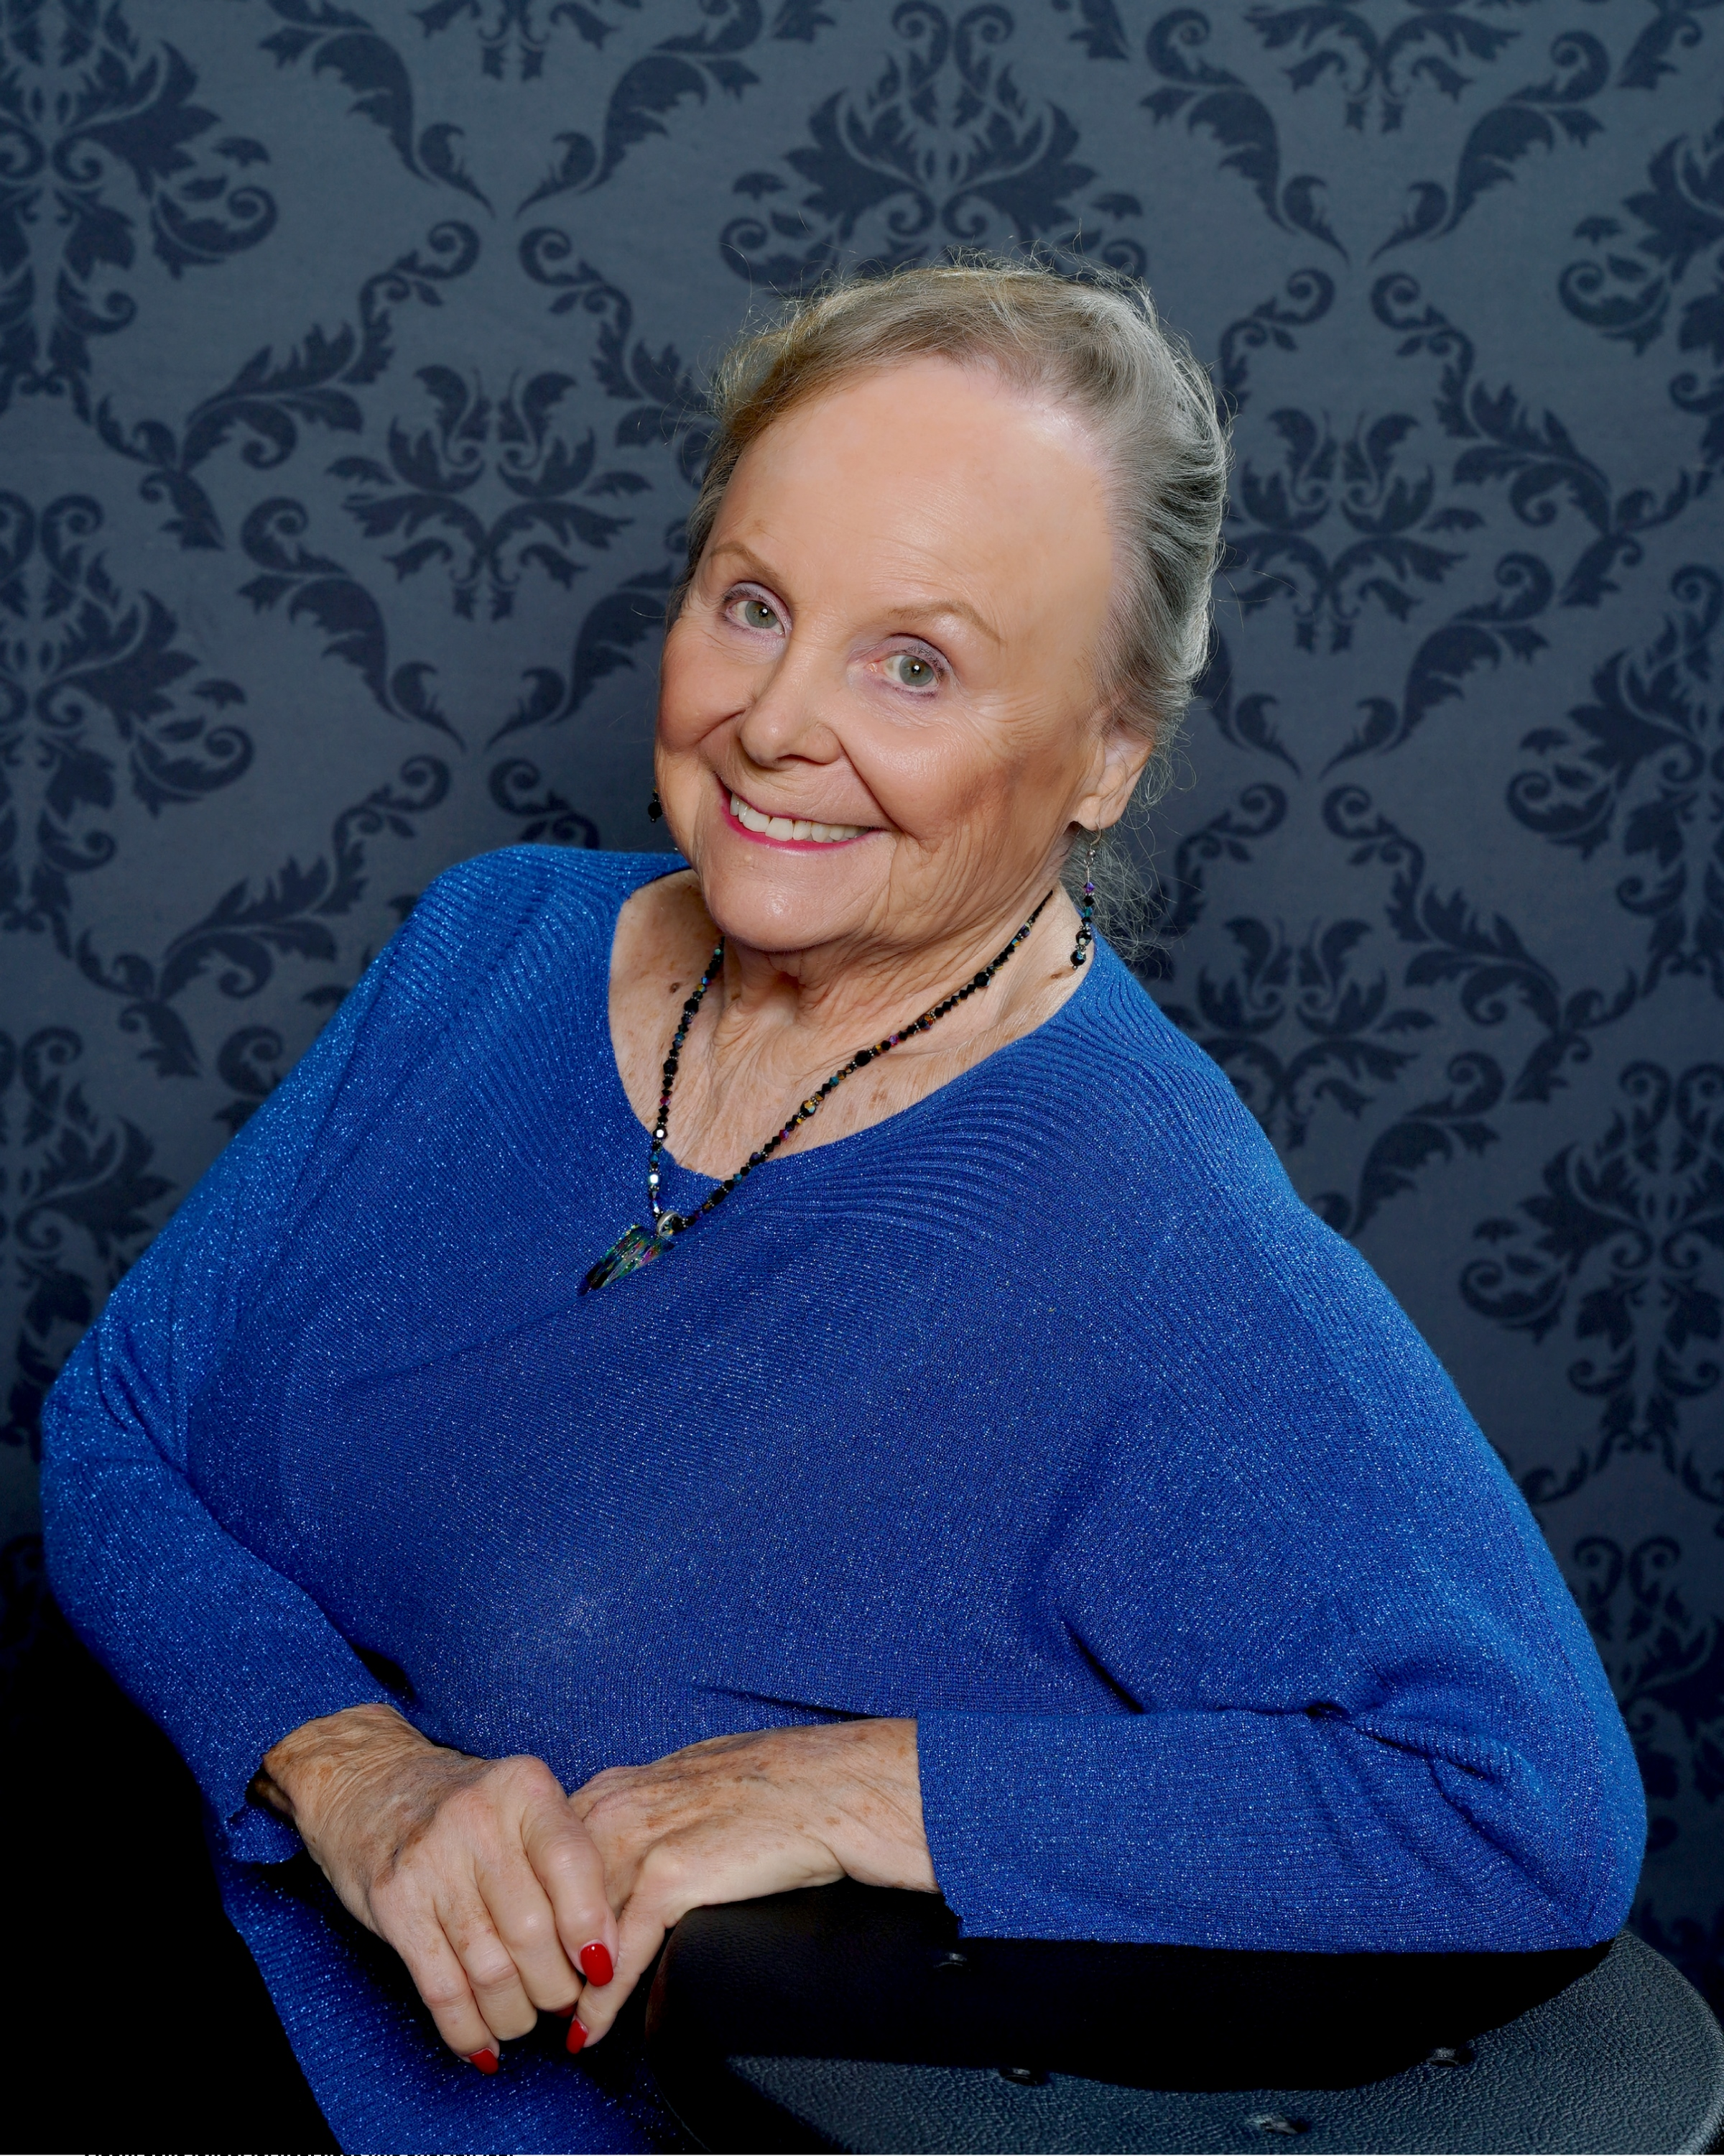
STANDARDIZED PATIENT
2015-2021  2012-2021 | Standardized Patient  Standardized Patient | Strategic Operations  USD School of Nursing
2009-Present | Standardized Patient | UCSD School of Medicine
November 2011 | TREDS Video | UCSD Dept. of Family & Preventive Medicine
THEATRE & ENTERTAINMENT
Dec. 2018 | An Old Fashioned Christmas | Lamplighter’s Theater
Oct. 2017 | Princess Diana The Musical | Patio Playhouse
March/April 2016 | Mack & Mable | Lamplighter's Theater
August/December 2015 | Variety Showcase | Balboa Park
May 2015 The Bridge – Staged Reading Poolhouse Project
April 2015 Cabaret Showcase Martinis Above 4th
March 2015 Variety Show Paradise Village
August 2014 Variety Show NewportBeachTea Room
July 2014 Variety Show BalboaParkButterflyGarde
 | August 2013 |  | Mornings at Seven, Staged Reading | La Jolla Theater Group
 | March 2013 |  | Mack & Mable, The Musical | Community Actors’ Theatre
 | September 2012 |  | The Effects of Gamma Rays on Man and the Moon Marigolds | Patio Playhouse
 | December 2011 |  | A Christmas Carol | Avo Playhouse
 | 2011 |  | Fiddler on the Roof | Lyric Opera, The Birch
2009 |  |  | Traditions of Christmas | CCT Musical Theatre, ECPAC
2010, 2009 |  |  | Senior Follies | CCT Musical Theatre, ECPAC
May 2009 |  |  | Swing | San Diego City College
2011, 2008, 2007 |  | North Park Vaudeville Show |  | North Park Vaudeville & Candy Shop
 | October 2013 |  | 100% San Diego – WOW Festival
 | 2015,2014, 2013, 2012, 2011, 2010 |  | San Diego Fair
 | April 2018 |  | Product Demo - Video for Welliq  Commercial shoot for Raindrop
 | Oct. 2017 |  | North County Transit District Photo Shoot
VOLUNTEER WORK
Volunteer for annual Christmas program for Camp Pendleton Marine Group in 2011, 2012, 2013 & 2015
The Fringe Volunteer 2013, 2014 & 2015

TRAINING AND EDUCATION

Enrique Toral – Vocal Coach
Laurie Romero – Vocal Coach
San Diego City College
Los Angeles City College

