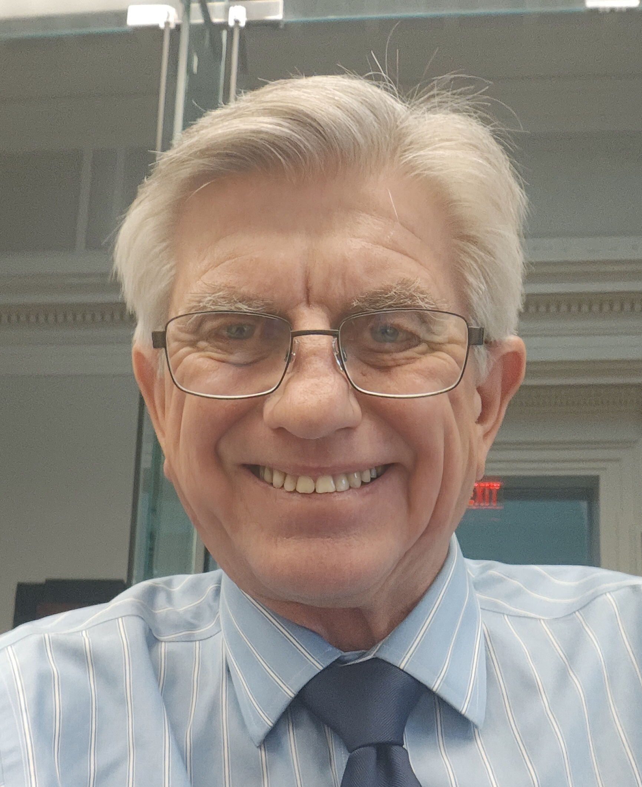
DAVID MICHAEL SHERIDAN
davidmsheridan1122@gmail.com 609-440-7328
SAG # 11510826

  - CREED II FBG STEVEN CAPLE JR
FILM
  - THE KITCHEN FBG ANDREA BERLOFF
  - THE UPSIDE FBG NEIL BURGER
  - MOTHERLESS BROOKLYN FBG ED NORTON
  - 21 BRIDGES FBG BRIAN KIRK
  - CREED BG RYAN COOGLER
  - GLASS BG M. NIGHT SHYAMALAN
  - EQUITY BG MEERA MENO
  - INSIDE GAME BG RANDALL BATINKOFF
  - WHAT IS LIFE WORTH BG SARA COLANGELO
  - ARMY OF THE DEAD FBG ZACK SNYDER
  - THE RETALIATORS BG BRIDGET SMITH
  - HUSTLE BG ADAM SANDLER
  - THE LADY IN THE LAKE BG ALMA HAR’EL
  - KNOCK AT THE CABIN BG M. NIGHT SHYAMALAN
  - AUDREY’S CHILDREN BG AMI CANAAN MANN
  - WHICH BRINGS ME TO YOU BG PETER HUTCHINGS
  - SERVANT BG M. NIGHT SHYAMALAN
  - CALL HER KING FBG ANDREW VAN DEN HOUTEN
  - THE ZOMBIE WEDDING FBG PAT PETERSON
  - SILVER STAR BG RUBEN AMAR
  - FANTASMAS FBG JULIO TORRES
  - SINKING SPRINGS BG RIDLEY SCOTT
  - BETRAYAL FBG NANCY GLASS

- ID CHANNEL FBG EPIC MYSTERIES, THE KILLER CLOSER
TV / CABLE
- OXYGEN CHANNEL FBG THE JURY SPEAKS (OJ TRIAL), METHOD & MURDER
- CARTOON NETWORK BG DELCO PROPER
- CNN FBG THE POPE: THE MOST POWERFUL MAN IN HISTORY ;
LINCOLN:AN AMERICAN PRESIDENT; JEFFERSON
- HBO FBG SUCCESSION, MARE OF EASTTOWN, HUSTLE
- NETFLIX FBG FRIENDS FROM COLLEGE, MESSIAH, LaREINA DEL SUR 2
- ABC FBG PHILA: THE GREAT EXPERIMENT – WORLD STAGE
- AMC FBG DISPATCHES FROM ELSEWHERE
- APPLE TV BG SERVANT; KNOCK AT THE CABIN; SINKING SPRINGS
- LIFETIME NETWORK FBG DEATH SAVED MY LIFE
- HULU FBG BETRAYAL
- NETFLIX. BG. THE RECRUIT

  - 3 DAYS / DON’T WALK P/FBG JOSE RODRIQUEZ
INDIE FILMS
  - THE HIDING FBG NICK DeROSE
  - WITHOUT YOU BG SONNY VELOSSI
  - THE CONDO BG DAVID ZHOU
  - THE SHADES (HEROIC EPISODES) FBG LISA REGINA
  - OFFSTAGE ELEMENTS BG FRANK LISA
  - DECAY P RYAN COLLINS
  - THE PEACEMAKERS P BELINDA WILSON/ ROZ FULTON
  - LE PARROT FBG RACHEL SONNENBERG

- PWC DIGITAL QUEST- LOCAL HEALTH FBG COHN CREATIVE GROUP
- TITLEIST GOLF PROMOTIONS FBG GLP CREATIVE GROUP
COMMERCIAL-INDUSTRIALS
- GIANT FOODS - TRAINING PHOTOS P/M GWEN THOMAS PR
- INVEN-TEL INFOMERCIAL P MARK SOLLEY
- 55+ COMMUNITY TOURS P GEOFF WILKINSON
- HOME DEPOT P/M GWEN THOMAS PR
- WAWA MUSIC VIDEO P BRIAN HARVATH
- WSFS COMMERCIAL BG KATIE GRIFFIN CASTING
- DISASTER RESPONSE TRAINING P HUMAN DOMAIN SOLUTIONS
- CAESARS CASINO BG KATHY WICKLINE CASTING
- DIVISION OF VETERAN AFFAIRS P PEOPLES TV
- HAND MODEL / MORTGAGE COM P/M LAMPHOUSE PRODUCTIONS
- COLONIAL PENN COMMERCIAL BG HAWTHORNE ADVERTISING
- RED CROSS P FRESH FLY LLC

ACTING TRAINING

*** PLAZA 7 MODEL AND TALENT AGENCY (PA) - ON CAMERA COMMERCIAL / PTV SESSIONS

