**STEFAN TOBDŽIĆ**

**Address Vitezova Karađorđeve Zvezde 17**

11050 Belgrade

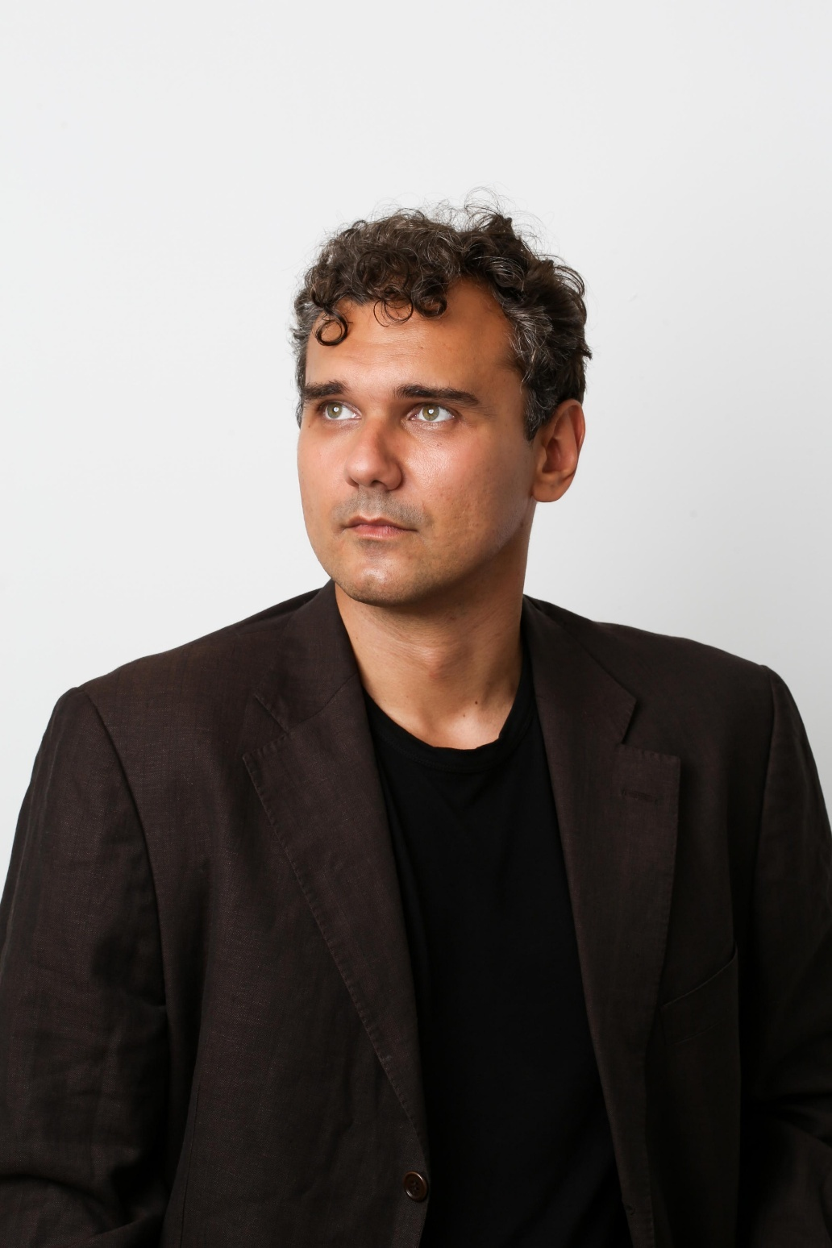

381 62/ 8275798

**E-mail:** stefantobdzic@gmail.com.

31.01.1988.

Instagram tobzic

LinkedIn Stefan Tobdzic

Model

Select Model Management

**Education**

**●** Lekart-

Graduate actor in Acting and Dirscting Class of Branislav Lecic

**Languagea**

● English C2 (Cambridge Certificate of Proficiency in English)

Spanish B1

Foreign projects:

Ark 3 -Engineer

Heads of State-John Cenas Stand In

Librarians Monk

Harvest-Man with the fedora hat

Family secrets – Eric Daines executive board member

Margin Scroseseez-Saints-Aristocrat

Serbian projects:

Konstantinovo Raskrsce 2 Vojnik JNA

U Klinču 3 - Kolega iz Iskrine klase

Tajna Vinove Loza 3 - Dostavljac

Igra sudbine-Englez

Igra sudbine - Policajac

Zakopane tajne - Doktor

Aviondzije-Pilot

Novogodisnji program RTS - Izbacivac

Popadija – Ozalosceni

Volja sinovljeva – Pokisli/Krvave glave

Ubice mog oca 7 – Ministrova pratnja

Aviondzije-Čovek 3

Music Videos :

Jasna Scepanovic-Juga-Glavna uloga Tito

Tanja Savic – Otac suzama mojim

Tea Tairovic – Bakšiš

Edita Aradinović

Natasa Bekalac i Sasa Matica- Prevaranti

Teodora Dzahverovic- Bruka

Oliver Tree-Bounce (Muzički spot) Spot Aleksandre Mladenović - Ja ne pijem mama

Maya Berovic i Sasa Matic-8 milijardi

Commercials :

Mozar kladionica

A1

Reklama VODAVODA

Reklama Chipsy

Reklama Superbet

Theater roles :

Teatar 011-Deo ansambla

Zvezdarski Vitez-Scena Braca Stamenkovic

Vidovdanski vidici-KUD Zitije-Vitez Cara Lazara

Hamlet

Sto te nema-Aleksa Santic

Opasne veze-Valmont Pozoriste Slavija