VINCENT ILLIA Las Vegas, NV • 702.677.7641
vince5585@aol.com • linkedin.com/in/vincent-illia-b733597

BRAND AMBASSADOR
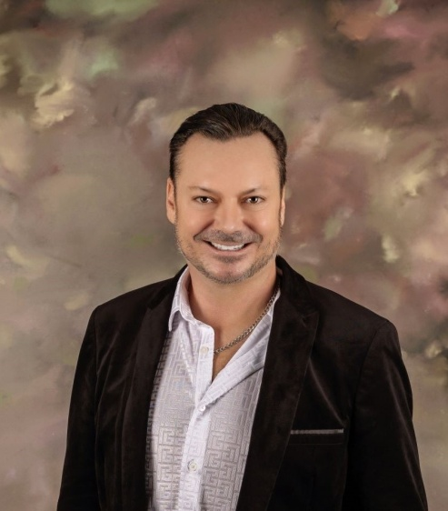 | Award-winning outside regional sales leader with 15+ years of outside sales in the transportation industry  Over a decade of national award winning professional public speaking & presentation experience  Current Nevada Alcohol Awareness Card Holder (TAM)  Pouring experience in the local Las Vegas market  Nevada Native who grew up in Las Vegas, Nevada
Professional Experience
Italian-American Club of Southern Nevada • Las Vegas, NV
Board of Directors, 2023- Current
Vice-President, 2003-2007
Board of Directors, 1999-2003
Founded in 1960, The Italian-American Club of Southern Nevada now has a membership of over 1,500 members and associate members. This non-profit organization hands out over $65,000 annually in scholarships to those students in need and of Italian-American decent. As Board of Directors member, I am in charge in registrations for all meetings, collecting fees, voting and participating in all Club related events and voting on all official club issues. I have also served as the youngest Vice-President ever elected and Advertising Chairperson that started the original website and newsletter program.
Education & Credentials
Bachelor of Arts in Speech Communications, University of Nevada | Reno, NV
Licensed Nevada Alcohol Education Card Certified to pour alcohol
Licensed Commercial/Industrial Real Estate Agent & Nevada Public Notary
Professional Organizations
Director | Italian American Club of Southern Nevada
Member | Southern Nevada Sons & Daughters of Erin
Member | CALV (Commercial Alliance of Las Vegas Realtors)

