Twana Barber
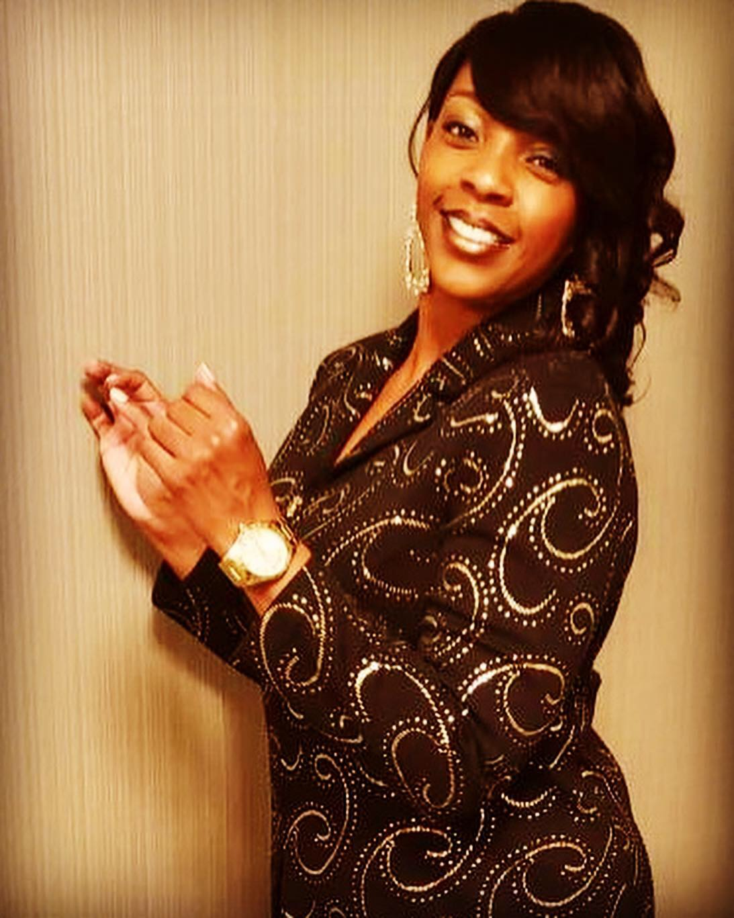
P.O. Box 201962
Saint Louis, MO 63121
Jazzy75@me.com

Personal Info
DOB: 9-7-79
Height: 5’7
Weight 155
Hair: brown
Eyes: brown
Tattoos: None

Theatre Experience:
The Buddy Holly Story M.C. Fort Worth, TX
Caroline or Change Caroline St. Louis, MO
Dreamgirls Denna) St. Louis, MO
Money Can’t Buy You Love Treasure St. Louis, MO
Power Money and Sex Diane Dallas, TX
The Wiz Dorothy St. Louis, MO
Bye Bye Birdie Student St. Louis, MO
Little Show of Horror Trio Atlanta, GA

Commercial Experience:
Delta Healthcare Service
Captain Crunch Cereal
Chili’s
Six Flags

Runway Experience:
Hype Hair Fashion Event Hyatt International Newark, NJ
Bridal Show America Center St. Louis, MO
Yoro Fashions Lambert Center St. Louis, MO

Training:
Hamilton Arts Academy Improvisation Kendell, St. Louis, MO
Barbizon Agency Modeling Natalie, St. Louis, MO
Central Visual & Perf Arts Vocal Music Ellis, St. Louis, MO
University of Arkansas Acting Pine Bluff, AR

Achievements/Special Skills
(List awards received)
Basketball, Tennis and Volleyball – 8 years
Traveling, Cooking, Reading, Singing, Acting Writing
Dialects: Southern, Standard America, Caribbean Singing: (alto), Zumba, Jazz Aerobics (instructor); Motivational Speaker, Horseback riding, MO Driver’s License

