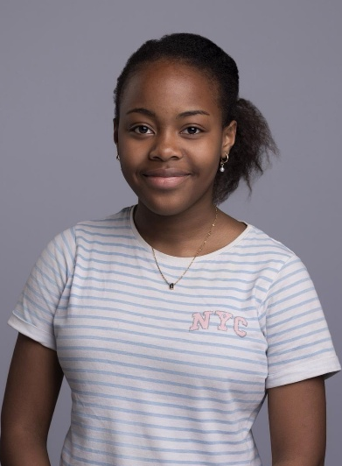
Deborah Mitchell
Date of birth: 09/11/2011
Location :Leidschendam, The Netherlands
Phone : +31 6 15356675
Email: dee.mitchell1@icloud.com

Objective
A passionate and dedicated young actor seeking opportunities to grow in theatre and on-screen performance. Committed to learning, collaboration, and bringing memorable characters to life

Theatre, Acting & Drama Experience

Night On Broadway – Ensemble/ Matilda Wormwood
AATG| 2023
- Participated in solo and group singing ,dance numbers, stage choreography and stage acting.
Bugsy Malone – Tallulah/Ensemble
British School In The Netherlands | 2023
- Lead character with responsibilities for acting , worked with scripts to memorize and deliver lines confidently and worked closely with cast.
Cinderella & Rockerfella – Ensemble
British School In The Netherlands | 2022
- Participated in group singing and dance numbers and stage choreography
Sound Of Music – Fraulein Maria
AATG | 2023
- supported younger children, sang and danced in group performances and worked closely with peers.

Training & Education
The British School in the Netherlands
Current Student
Received ongoing drama education with a focus on performance, ensemble work, and creative expression. Actively participated in school productions and drama projects, gaining experience in stage acting, singing, and collaborative storytelling. Worked with scripts and props to develop scenes, strengthen memorization skills, and enhance character development. Regularly performed in group settings, building confidence, communication, and stage presence.
AATG (The Anglo-American Theatre Group-The Hague)
Student Performer
Completed focused training in acting and performance through AATG’s structured theatre program. Developed core acting techniques including character development, emotional expression, stage movement, and voice control. Worked intensively with scripts to explore dialogue, timing, and scene study, and gained hands-on experience with props, blocking, and stage direction. Participated in rehearsals and live performances that emphasized professionalism, discipline, and collaboration. Built confidence and versatility as a performer while learning to take direction, analyse characters, and perform effectively in both ensemble and individual roles.
Student Performer LAMDA (London Academy of Music & Dramatic Art) – Level 6 Musical Theatre
Student Performer
Currently undertaking LAMDA Level 6 in Musical Theatre, with a focus on advanced vocal performance, acting through song, and expressive movement. Developing skills in interpreting both classical and contemporary musical theatre repertoire, with emphasis on character development, emotional connection, and storytelling through music. Actively working on solo and ensemble pieces to strengthen stagecraft, vocal technique, and performance confidence. Engaging with a variety of musical styles and scripts to build versatility and deepen understanding of professional performance standards. Gaining experience in rehearsing and refining pieces for assessment and live performance, enhancing communication, stage presence, and artistic expression.

Representation
Currently seeking representation

Additional Activities and skills
- Strong memorization and line delivery
- Emotional expression and stage presence
- Teamwork and communication
- Takes direction well
Sports – intermediate skier, swimming
Poetry Club – The British School in the Netherlands
Engaged in creative writing, poetry reading, and group discussions. Developed writing, public speaking, and creative thinking skills.
Drama Club – The British School in the Netherlands
Participated in group acting activities, theatre games, and small performances to build confidence and teamwork.
Student Council – The British School in the Netherlands
Actively contributed as a dedicated member of the Student Council, representing student voices and working collaboratively to improve the school community. Participated in organizing events, leading initiatives, and supporting school-wide projects. Developed strong leadership, communication, and teamwork skills while demonstrating responsibility, commitment, and initiative.

.
.

