FREYA MULLEN

ADDRESS: Harlington, Bedfordshire  EMAIL: freyamullen06@gmail.com  MOBILE: 07856 772027  HAIR: Long/Scandinavian Blonde  EYES: Blue  AGE: 18 (playing age 13-21)  HEIGHT: 5 foot 3 inches  BUILD: Slim  TRAINING: Parados Theatre School, Stagecoach  SINGING: Soprano/Mezzo Soprano  DANCE: Jazz, Modern  ACCENTS: Native RP, Cockney, Standard/Southern USA,  Standard Australian  SKILLS: Piano, Ice-skating | 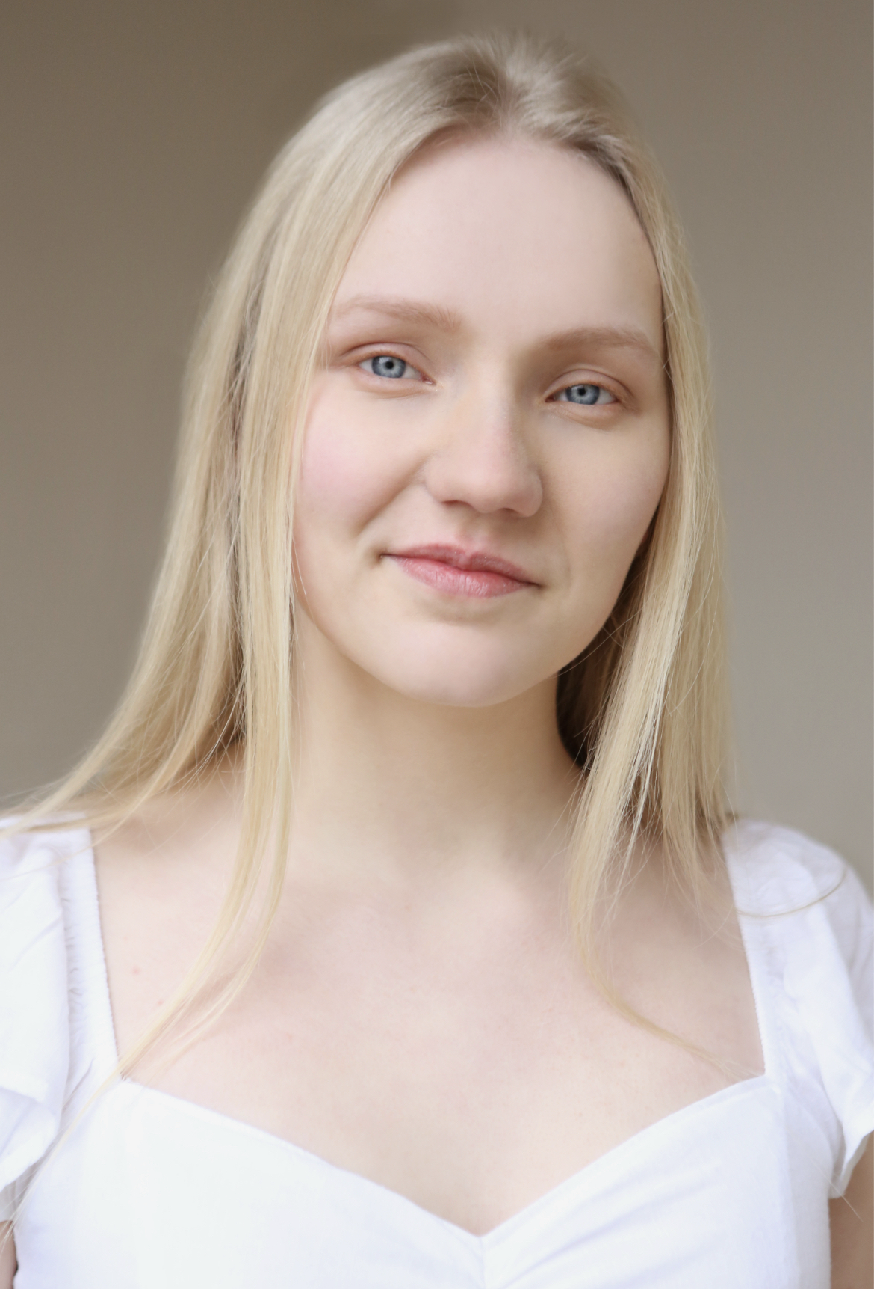

CREDITS
ROLE | PRODUCTION | TYPE | YEAR
FAIRY GODMOTHER | SLIPPER AND THE ROSE | THEATRE | 2025
BENNY | GUYS AND DOLLS | THEATRE | 2024
LYDIA BENNETT (Originated) | PROPOSALS ( A new musical) | THEATRE | 2024
WIDOW TWANKY | TROUBLE IN PANTOLAND | PANTO | 2024
ENSEMBLE | GODSPELL JR* | THEATRE | 2024
VITTORIA | THE GONDOLIERS | OPERETTA | 2023
SANDY | GREASE | THEATRE | 2023
ENSEMBLE | BROADWAY THROUGH THE AGES | THEATRE | 2023
ANNA | FROZEN JR* | THEATRE | 2023
ENSEMBLE | HMS PINAFORE | OPERETTA | 2023
LADY MONTAGUE | ROMEO AND JULIET | THEATRE | 2022
HELENA | A MIDSUMMER NIGHT’S DREAM* | THEATRE | 2022
THE WITCH | INTO THE WOODS JR* | THEATRE | 2022
GODMOTHER DROSSELMIER | THE NUTCRACKER* | THEATRE | 2021
GRACE | BRAINSTORM | THEATRE | 2021
ORPHAN/PICKPOCKET | OLIVER! | THEATRE | 2018
MAID MARION | ROBIN HOOD AND FRIENDS | THEATRE | 2016
 | *performed for Parodos Theatre School
AWARDS
BEST YOUTH PERFORMER (NODA East Awards 2025) for WIDOW TWANKY in Trouble in Pantoland
BEST YOUTH PERFORMER (NODA East Awards 2023) for THE WITCH in Into The Woods Jr.
COMMENDATION (NOVA Personal Awards) for WIDOW TWANKY in Trouble in Pantoland
GRADE 8 Music Theatre LCME (Distinction)
GRADE 5 Piano ABRSM
A-Level Drama and Theatre Studies

