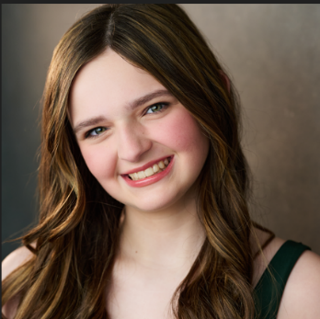
KYRA HELENA COOPER
571-634-2946
justkyranacat@gmail.com
@kyra.coop.theatre.92
43277 Overview Pl.
Leesburg VA 20176

local: DMV | hair: light brown | eyes: green | height: 5’6”

THEATER
Production | Role | Theater/Location
Mean Girls the Musical | Gretchen Weiners | Infinite Arts – Leesburg VA
Billy Elliot | Dead Mum/ Clipboard Woman/Keeley/Woman 2 | Infinite Arts – Leesburg VA
Mamma Mia | Lead Ensemble | Moon River Productions – Leesburg VA
17 Again | Principal Masterson | Infinite Arts – Leesburg VA
Footloose | Lead Ensemble | Moon River Productions – Leesburg VA
Harry Potter and the Cursed Child: High School Edition (state premiere) | Ms. Book/Ms. Waldorf/Old Lady Dorthea | Moon River Productions – Leesburg VA
James and the Giant Peach | Spider | Infinite Arts – Leesburg VA
High School Musical 1 and 2 | Martha Cox | Infinite Arts – Leesburg VA
Pippin | Lead Ensemble/Dancer | Infinite Arts – Leesburg VA
Wonderland High | Rose | Infinite Arts – Leesburg VA
Catch Me if You Can | Cindy | Infinite Arts – Leesburg VA
The Brothers Grimm Spectaculathon | Girl | Moon River Productions – Leesburg, VA
Elf the Musical | Fake Santa 1 | Infinite Arts – Leesburg VA
Almost, Maine | Suzette | Moon River Productions – Leesburg, VA
The League | Britt | Infinite Arts – Leesburg VA
Headrocks | Hannah | Infinite Arts – Leesburg VA

FILM & TV
One Family Dance Documentary- Loudoun School of Ballet
TRAINING
Acting for Young People High School Musical Intensive – George Mason University – Summer 2025
Voices Rising – Parkview High School – October 2025
B Acting Studio- Brigette Thieme Burdette – Acting lessons since January 2025
Stage Coach – Linda Cirba – Voice Lessons since 2023
Honors Chorus- Select Treble Riverside High School
District Chorus – 2023-2024
Rise Dance Center – Private Dance lessons from 2024- Present
SPECIAL SKILLS- Sight Reading, Piano, Music Theory, Improv, Range G3 to D6, Video Editing, Photography, Accents include British, Cockney, Geordie, MLE

