**Jayce Johnson**

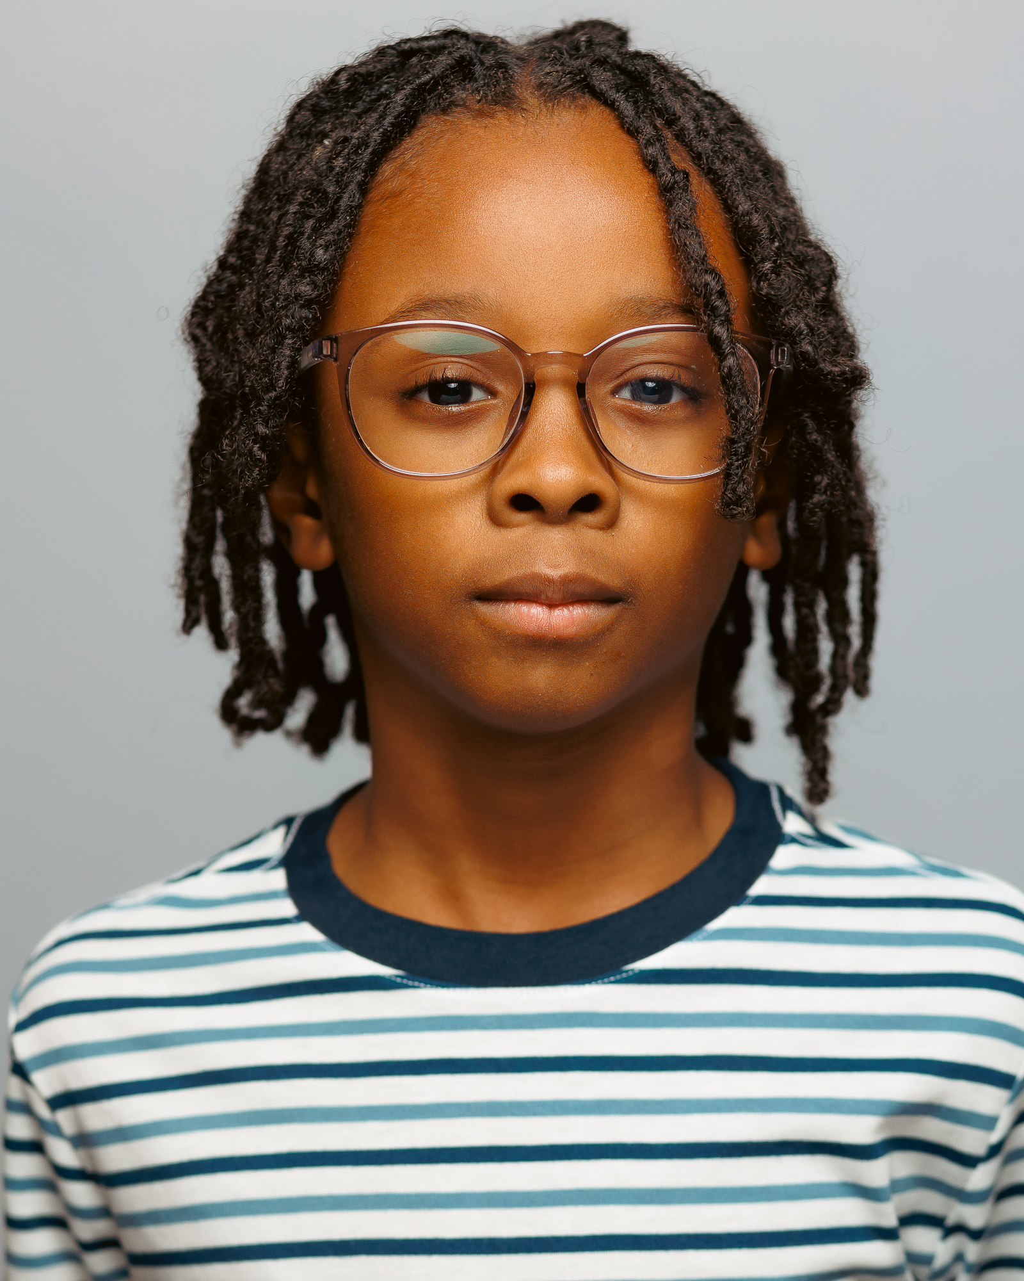

**Height: 4’9 Weight: 70lbs**  
**Phone: 205-240-8969 Email: wethejohnsonkids@gmail.com**  
**Location: Birmingham, Alabama**

### **TELEVISION & COMMERCIALS**

|  |  |  |
| --- | --- | --- |
| **Production** | **Role** | **Production Company / Director** |
| *Loves Path* (Commercial) | Actor | Reeds Jewelers / Wallaby Media |
| *Flashlight* (Music Video) | Actor | Yelawolf / Patrick Tohill |
| *Workman's Comp LLC (Compman)* | Compman | Soup Factory Digital |
| *Leadership Learning* | Boy Bike Rider | Cedar Creative |
| *Alabama Tourism* | Background (Mobile Battleship Memorial) | Intermark Group |

### **FILM**

|  |  |  |
| --- | --- | --- |
| **Film Title** | **Role** | **Director / Production Company** |
| *Last Shot* | Background | Andy Palmer |
| *End the Wait* | Background | Dean Cain & Randy Simpkins |

### **TRAINING**

* GS Workshops: *Getting Started 205*
* *Acting/Modeling 101 eCourse*

### **SPECIAL SKILLS**

Adventurous • Bike Riding • Jump Rope • Polite • Well-Spoken • Basketball • Football • Golf • Martial Arts • Hip Hop Dance • Modeling