**HEATHER LEIGH CAMERON**

FILM AND TV RESUME

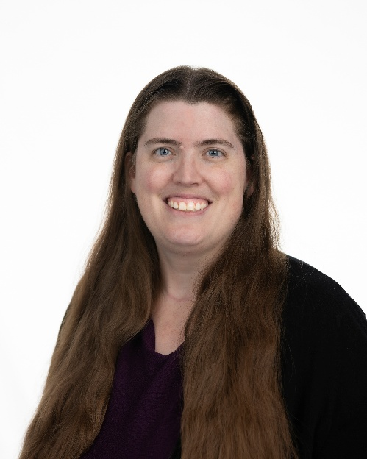

CONTACT DETAILS

Lethbridge, Alberta

Email: heather.leigh.cameron@gmail.com

Phone: 403-715-0601

Represented By: Faces of Wendy

EDUCATION

Certificate in Family History Research

Pathway Worldwide

Brigham Young University Idaho Online

Certificate in Administrative Assistant

Pathway Worldwide

Brigham Young University Idaho Online

Diploma in Communication Arts: Print Journalism

Lethbridge College

FILM/TELEVISION/ONLINE WORK

Star Trek: Venture – A Moment’s Peace Short Film Dr. T’Mai ManAtDeskProductions

Once Upon A Crime Episode 6 Sister Maria Euphemia Results Entertainment

Once Upon A Crime Episode 6 Violet Pennington Results Entertainment

Once Upon A Crime Episode 5 Violet Pennington Results Entertainment

Once Upon A Crime Episode 4 Violet Pennington Results Entertainment

Once Upon A Crime Episode 3 Violet Pennington Results Entertainment

Robin the Hood - A Wild West Adventure Episode 8 Mona Stangley Results Entertainment

Robin the Hood - A Wild West Adventure Episode 7 Mona Stangley Results Entertainment

Robin the Hood – A Wild West Adventure Episode 6 Townsfolk Results Entertainment

Robin the Hood - A Wild West Adventure Episode 3 Mrs. Ryder/Townsfolk Results Entertainment

Robin the Hood – A Wild West Adventure Episode 2 Townsfolk Results Entertainment

Robin the Hood – A Wild West Adventure Episode 1 Townsfolk Results Entertainment

Angel Dust Episode 2 Kim Factory Film Studio

The Hadlee Projects Short Film Blender Girl Great Canadian Films

Table Read Tuesdays Various Characters Cypher Studios

Ava Thompson Short Film Endless Winter No Budget Productions

Sci-Fi Con Attendee Film Nouveaux Arrivants Société cInéMAGINE del'Alberta

Trekkie Feud Episode 2 Member of Team JG Hertzler Gaaays in Spaaace

TRAINING

Improv! Meredith Nudo Disabled Voice Actors Database

DGC Permittee Status DGC Alberta

Traffic Control Persons for Construction – Flagger Safe Training Online

Ultimate Production Assistant Workshop Brock Skretting DGC Alberta

Breaking In: The Next Step Carolyn J. Carpenter Hollywood Gatekeepers

Self Tape Workshop for Actors Gin Fedotov Lethbridge Independent Film Society

ACTRA Background Performers Info Session ACTRA Alberta

Safe Sets™️ COVID-19 (Level A) Safe Sets International

Set Etiquette Sarah McKenzie I.A.T.S.E. Local 212

Motion Picture Orientation Sarah McKenzie I.A.T.S.E. Local 212

Delving Into Shakespeare’s World Armin Shimerman Antaeus Theatre Company

Shakespeare’s Rhetoric Masterclass Armin Shimerman Antaeus Theatre Company

The Meisner Approach Part Deux Sally Cacic Morpheus Theatre

The Meisner Approach Sally Cacic Morpheus Theatre

Scene Rehearsal Ezequiel Rubin Cinelab Film School

Acting Class Logan Arneson Acthound NYC

Find the Emotion the Scene Needs Kirsten Clarkson Screen Acting School Online

Easy Improvisation Shawn Kinley Morpheus Theatre

Beginning Acting Debbie Reynolds Performing Arts Studio Online

Stage Manager Workshop Rebecca Miller Lethbridge Sterndale-Bennett Theatre

Character Performer Workshop Derek Scott CASA Lethbridge

SPECIAL SKILLS

Journalism/Photography, Singing, Photography, Clarinet, Driver’s License, Dual Citizen of Canada and the U.S. with Passports, Social Security Number, Social Insurance Number.