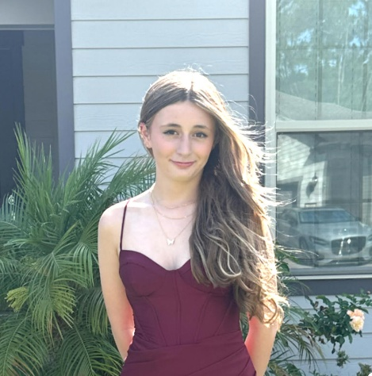
Hayden Jacobs
Age:14 Height 5”7/Hair: Brown/Blonde, Eyes: Brown
Contralto/Mezo-Soprano, Traditional/Mex-Belt
Contact: Amanda Jacobs
Cell: 601-978-0305
Email: Grussaute55@Gmail.com
Location: Ponte Vedra, Fl
Educational Theater
Hadestown Eurydice Greenlight Theater Co
Sister Act Celeste/Joey Greenlight Theater Co
Legally Blonde Ensemble/Judge Greenlight Theater Co
SpongeBob the Musical Karen Greenlight Theater Co
Six the Musical Jayne Seymore Ensemble Greenlight Theater Co
Matilda School Edition Miss Honey Greenlight Theater Co
Be More Chill Ensemble Greenlight Theater Co
Anastasia School Edition Dowager Empress Greenlight Theater Co
Top Girls Nell St Johns Stage
Secret Garden Alice/Children St Johns Stage
Headless Horseman Rides Again Jodi St Johns Stage
Wizard of Oz Chorus St Johns Stage
Concert Night/Cabarets
Brewhound Burn/In His Eyes Greenlight Theater Co
Strings Brewery She Used to be Mine Greenlight Theater Co
Deck the Chairs Six Jayne Seymore Greenlight Theater Co
Broadway “Burn” Hamilton Soloist Island Theater
Princess “In My Dreams” Soloist Island theater
Access Broadway Regionals 2023 Florida Best Musical Theater Studio St Johns Stage
Access Broadway Nationals 2023 Best Performing Arts Studio St Johns Stage
Training
Vocal Training Derek Klena
Individual Training- Vocal/Acting Chris Milligan
Musical Theater Dance/Vocal/Acting Training Greenlight Theater
Ballet/Tap/Hip-Hop/Contemporary/Vocal/Acting St Johns Stage

