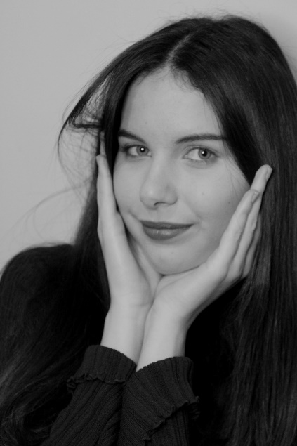
FELICITY O’TOOLE
DOB: 23/01/2006
Phone: +44 7988106714
Email : Felicityemmagraceotoole@gmail.com
Height: 5ft 8
Weight : 9 Stone
Eye Colour: Green/grey
Hair Colour : Brunette
Hair Type: Wavy

Relevant Education + Training
2023 – 2024: B-Tech Level 3 Extended Certificate in Performing Arts (Distinction)
2019 – 2022: GCSE Drama (Grade 8)
2021: Paper birds theatre company – Physical theatre workshop intensive
2022 – Frantic assembly workshop
2017 – 2019 – St Augustine’s Academy - Drama and Theatre classes
2015 – Hazlitt theatre youth group (one year theatre training)
2012 – 2014: JAG Dance Academy – Musical Theatre Training

Experience
The Memory of Water – Catherine – Maplesden Noakes Performing Arts Department (2024)
Romeo and Juliet – Lady Montague – Maplesden Noakes Performing Arts Department (2023)
Hairspray – Amber Von Tussle – St. Augustine’s Academy (2022)
‘Be My Baby’ – Mary – St. Augustine’s Academy (2022)
Oliver Twist (Jr) - Mrs Sourberry - St. Augustine’s Academy (2018)
Matilda the musical - Matilda Wormwood - St. Augustine’s Academy (2018)
We will rock you - Ensemble - St. Augustine’s Academy (2017)
Seussical the musical - JoJo - St. Augustine’s Academy (2017)
The Grinch – Ensemble - Hazlitt Theatre (2015)
Shrek the musical mashup – Ensemble - JAG Dance Academy (2013)

Special skills
- Acoustic Guitar (beginner)
- Accents – American (General, Southern), Australian, British, Cockney
- Singing (Alto)

Personal Statement
I am a hard-working and focused emerging actress with an unstoppable passion for working in the industry. I love nothing more than storytelling and bringing characters to life. Collaborating with other actors and creatives inspires me endlessly, and I truly enjoy doing so. My dedication ensures that I always give my all, putting my heart and soul into every second of preparation, rehearsal, and performance. I have excellent communication skills and enjoy carrying out extra research relevant to the character and project I am involved with, paving the way for an authentic and meaningful performance. I am incredibly ambitious and have been working hard to improve my skills through classes, training, and self-study from a very young age. I achieved a high grade 8 (A*) in GCSE Drama and received an overall distinction in Performing Arts in further education. I was also awarded the ‘Best Actress’ award at the annual St Augustine’s Academy Awards Evening in 2022, in recognition of my commitment to the subject, strong theoretical understanding, and authentic final performance. I am currently working on my very own short film, What Remains of Missy, which I completed earlier this year. When I’m not acting, I’m almost always writing. I published my first novella in 2023 and love writing scripts that I hope will one day be brought to life.

