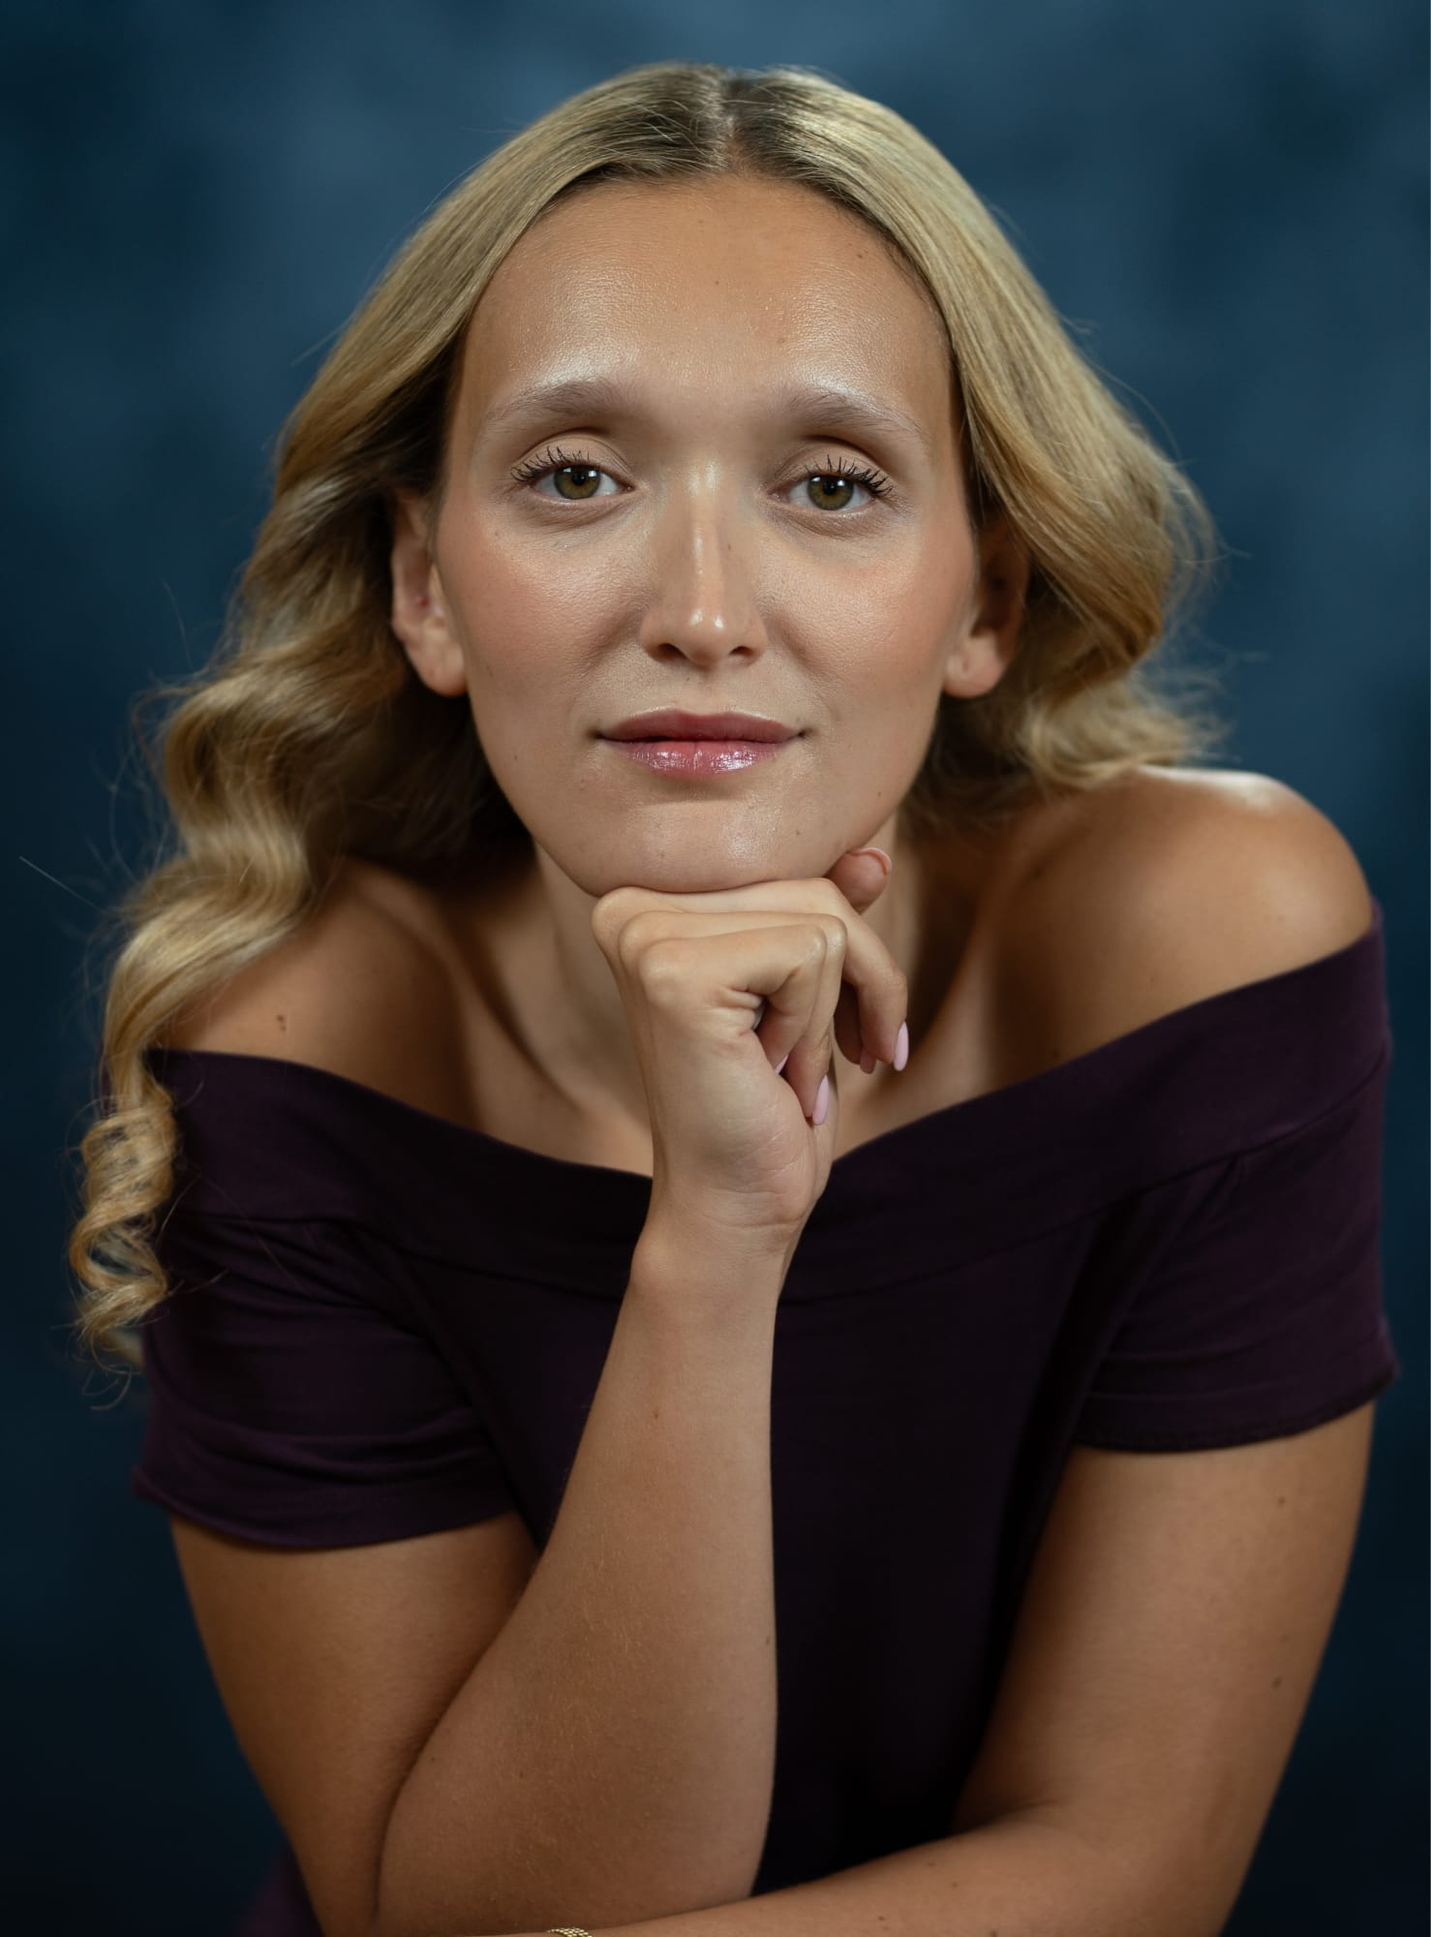
Elizabeth Blayne
Actress

Email: lizblayne1726@gmail.com

Mobile: +44 (0) 7446299453

Height:

Build:

Eyes:
Hair:

5’4” (164cm)

Slim/Toned
Green Hazel
Blonde

Nationality:

Playing Age:

Languages:

British (French)
18-‐30
English, French (Fully Bilingual)

Vocal Range:
Spotlight Account:

Mezzo Soprano
https://app.spotlight.com/3578-7836-9333

Education

2023-2023 RADA, London Acting Foundation Degree (Graduate)
2021-2022 L.S.E., London MSc in Conflict Studies
2017-2020 King’s College London BSc in Philosophy, Politics & Economics

Additional Acting Training

2020 | Royal Central School of Speech & Drama | Acting for Camera (part time course)
2019 | Royal Central School of Speech & Drama | Stage Combat Level 1 (2 weeks workshop)
2018 | Royal Central School of Speech & Drama | Audition Techniques (part time course)
2017 | A Level DRAMA
2015 | National Youth Theatre (NYT) | Performing Shakespeare, Summer course

CREDITS
Ragged Claws |  | Maggie Hawthorne |  |  | Baron’s Court Theatre (2025)
Hamlet |  | Polonius |  |  | RADA (2023)
The Distance Between Us |  | Writer/ Director |  |  | RADA (2023)
The Philistines |  | Tatiana |  |  | RADA (2023)
Therese Raquin |  | Therese |  |  | RADA (2023)
Eilat International Dance Festival |  | Principal Belly Dancer |  |  | London UK Troupe (2019)
Twelfth Night |  | Viola |  |  | RCSSD (2018)
Marat Sade |  | Marat |  |  | Senior School (2017)
 | Representation
Agent: AP TALENT MANAGEMENT: Pip Gofton

Other Skills & Interests

Accents: British RP; General American; French
Music: Contemporary, Pop and Musical Theatre Singing; Piano Grade 3
Dance: Ballet; Jazz; Belly Dancing
Skills: Shotokan Karate (Black Belt); Kick Boxing (Children’s Instructor); Ice Skating; News & Current Affairs

