Milla Jocelyn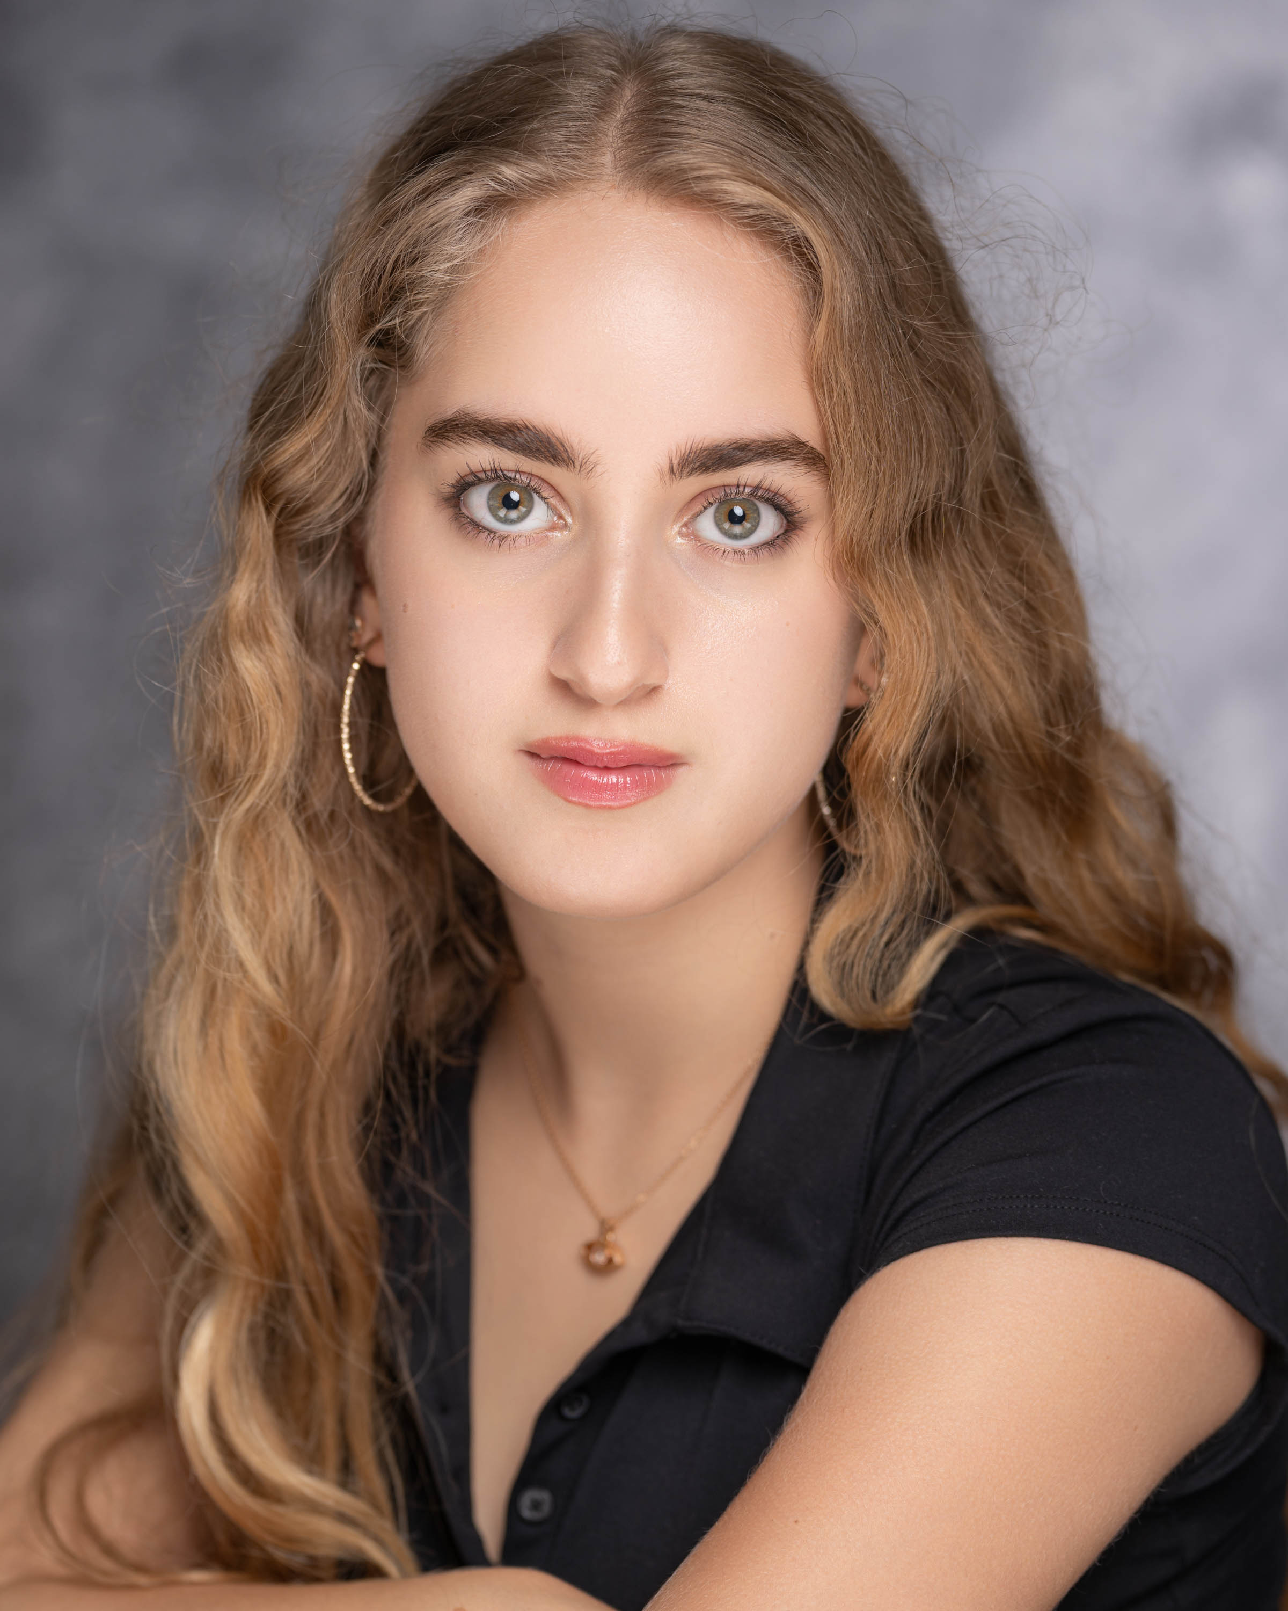

[Contact-millajocelyn1@gmail.com](mailto:Contact-millajocelyn1@gmail.com)

**Number:** +44 7398860988

**Objective-** I am a confident and driven 16-year-old seeking a part-time position where I can bring my strong customer service skills, natural people skills, and ability to work well in a team. With a proven track record of reliability, excellent timekeeping, and a willingness to learn, I’m ready to make a meaningful contribution in a fast-paced, customer-focused environment.

* Skills and abilities- **Excellent People Skills**
* **Customer Service Mindset** – Friendly, approachable, and professional; always focused on making others feel welcome and valued.
* **Teamwork & Collaboration**
* **Strong Communication & Presentation**
* **Reliable & Organised**
* **Adaptable & Quick to Learn**
* **Creativity & Big Energy**  
  I’m naturally upbeat, funny, and full of positive energy — the kind of person who lights up a room without trying. My sense of humour, quick thinking, and quirky personality help me connect with all kinds of people. I love bringing good vibes to any team and believe that a bit of laughter and creativity can go a long way in making work more enjoyable (and productive).

Experience- Although I haven’t held a formal part-time job yet, I’ve had plenty of real-world experience that’s prepared me to thrive in a working environment. Over the summer, I took part in Mark Jermins *Industry Week,* a 5-day residential programme designed for young actors looking to train at a professional level. It was an intense, hands-on experience where I worked closely with a team to create, direct, and star in an original short film that went on to win the programme’s film event. I was praised for my adaptability, creative input, and ability to take direction professionally all in a fast-paced setting. Throughout my time at Redcliffe Gardens and Queen’s Gate School, I also developed a strong foundation in work-ready skills. From leading group projects to presenting in front of full assemblies, I learned how to manage deadlines, communicate clearly, and collaborate effectively. I was regularly recognised for my positivity and people skills — including being awarded the *Spirit of the School* prize multiple times, a reflection of my energy, reliability, and ability to bring people together. Even without formal work experience, I’ve learned what it means to show up, give 100%, and work like someone who has.

**Education-** Redcliffe Gardens School, London (Primary)  
*8 years*  
A remarkable school experience where I grew not just academically but personally, embracing values like kindness, courage, resilience, perseverance, confidence, and adaptability — qualities that have shaped who I am today.

Queen’s Gate School, South Kensington (secondary**)**  
*5 years*  
Completed my GCSEs, excelling both academically and personally. I was honoured with awards such as the *Spirit of the School* prize, recognising my positive attitude, outstanding people skills, and leadership.

**Interests-** I’ve been skiing since I was three, and over the years I’ve worked my way up to black runs, jumps, and even skiing backwards, I've worked my way up to that level thanks to the perseverance, courage, confidence and resilience I developed during my years at Redcliffe. — it’s one of my favourite ways to challenge myself and have fun. I’m also deeply passionate about acting. I take weekly acting classes. I also love reading, going to the cinema, and spending time with my childhood best friends and close family friends. I also prioritise fitness and self-care as staying active and looking after myself is important to me.

**Key Skills**

* Excellent communication and people skills
* Confident, clear presenter with strong stage presence
* Team player with natural leadership qualities
* Reliable, organised, and punctual
* Quick to learn and adapt in new environments
* Creative thinker with a positive, energetic attitude
* Strong sense of self-discipline and resilience

**Why I’m Applying-**I’m looking for a part-time role where I can bring my energy, people skills, and reliability into a real working environment. I love meeting new people, learning quickly, and taking on responsibility and I’m excited to prove myself as someone who can make a genuine contribution.