LAURA MONTESINOS 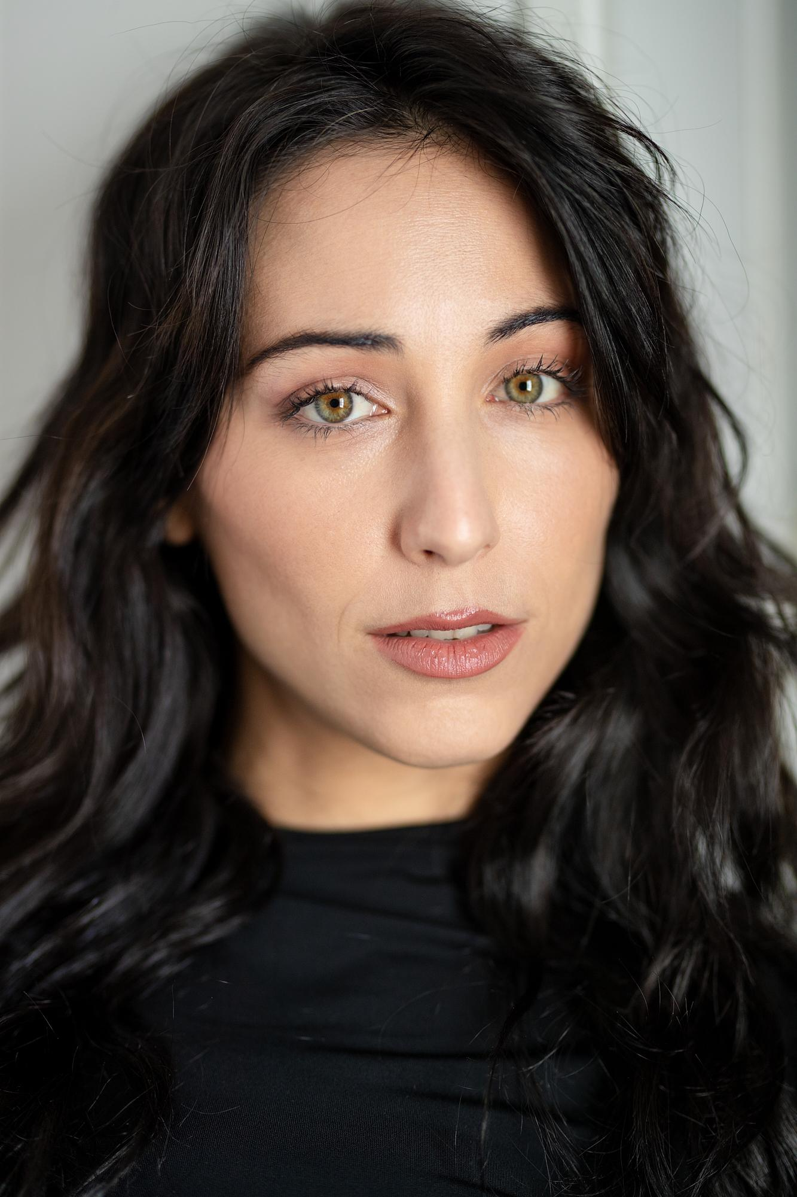

Madrid, Spain
(+34) 660 652 801
07/03/1993
lauramontesinos43@gmail.com
https://www.instagram.com/lauramontesinos43/
Manager in Spain: https://www.unicarepresentaciones.com/actores-actrices/laura-montesinos
IMDB page: https://www.imdb.com/name/nm8651934/

TELEVISION
4 STARS - TVE. Good Mood. A daily show that started in march 2023 and it’s been seen for more than 4 million people every day since then. Still on air at the most important national channel (TVE). / Supporting Actress

TEFIA NIGHTS - Atresplayer. Buendia. Directed for one of the most important directors of Spain, Miguel del Arco, with actors like Patrick Criado (Money Heist, Netflix), Carolina Yuste (Spanish Academy Award winner), Roberto Álamo (two times Spanish Academy Award winner), Israel Elejalde (“Parallel Mothers”, Pedro Almodóvar)... / Supporting Actress

TO SERVE AND PROTECT - TVE. Plano a plano. A show that ran from 2017 to 2023 at the most important national channel (TVE) with almost 2 million viewers daily. / Supporting Actress

*others:
FRIPOZO / Commercial / Antiestático Europa SL / Main Character / National TV commercial with one of the most important food product brands in Spain since 1935.

LINEA DIRECTA / Commercial / Pueblo Films / Main Character / National TV spot where I worked with a 2 times academy award winner Nacho Diaz (FX effects of Game of Thrones, The last of Us, House of the dragon, The Hobbit… )
FANTASMAGORIC NIGHTS 2022/2023 / FANTA / Main Character / A terrifying experience streamed live on Twitch by AuronPlay (14 million followers on twitch and more than 30 million on youtube) and Ibai Llanos (15,2 million followers on twitch and 11,3 million on youtube)
TAURUS-HOME / Dir. Kike Doatis / Main Character / Spot TV / The national spot of the 60th anniversary of the home appliances brand

MICHELIN - Trendy Road Trip con Cristina Pedroche / Spot Youtube / Main Character

LIFE IS A DREAM - Aldo Narejos / Videoclip with Berto Romero and Ana Morgade, two of the most famous comedians in Spain / Dancer

DAYS OF JOY - Salvador Beltrán / Videoclip / Sony Music / Supporting Actress

LIVE SHOWS
Casting by Kevin Porter (Warner Bros Park US) and approved by DC comics to be the European Image of “Supergirl”, “WonderWoman”, “Harley Quinn”, “Catwoman” and “Poison Ivy” in WARNER BROS PARK, both in Meet & greet and live shows (Gotham City Stunt Show).

FILM
POPCORN - Dir. Mónica Dolado - shortfilm - Valkyrie Film Fest of New York among others. With Mario de La Rosa (Money Heist, Netflix), Andrea del Río (Mar de plástico, Amazon Prime), Sandra Martín (La Gran familia Española, Netflix) / Main Character

NOTES ON A SUMMER - Dir. Diego Llorente / Official selection at IFFR (Rotterdam), D’A (Barcelona), BAFICI (Buenos Aires), etc / Supporting Actress

30 SECONDS - Dir. Mina El-Hammani (Elite, Netflix) / Quiet Productions / Shortfilm / Supporting Actress

LOVE IN FOUR PHASES - Dir. Kike Doatis / Axel Hotels / Fashion Film / Main Character

METANOTODO - Dir. Elena Rey / Finalists Notodofilmfest 2020 / Main Character

PEOPLE WHO DON’T KNOW WHAT THEY WANT - Dir. Alex Ygoa / Shortfilm / Main Character

DATE’S DECONSTRUCTION - Dir. Alex Ygoa / Shortfilm / Film Fest of Washington, Ibiza, Tarazona, etc / Main Character

PARADOXES IN THE DAILY LIFE OF A SCHOOL OF FISH - Dir. Manuel Manrique / Shortfilm / Main Character

VERONA’S OPERATIVE - Dir. Samuel Garar / Shortfilm based on Romeo & Juliet play / Supporting Actress

BABY, IT’S NOT SO DIFFICULT - Dir. José Fernández-Ark / Shortfilm / Main Character

THEATER
JAULAS (JAILS) - Dir. Rubén Cano / Spanish Theater / An immersive play played in the most important theater in Spain for 3 years. / Main Character.

90’S SONS - Lara Theater / Dir. Lucia Estevez (Actress, director and musical theater teacher in SOM Academy https://somescuelademusicales.com/ (Mamma Mia!, Chicago, Matilda, West Side Story… ) Four seasons with SOLD OUT every week. (August 2021 - February 2024). / Main Character.

THE GUILTY - Federica Colucci - Dir. Carlos Be (director and writer of plays played in New York, Bolivia, Chile, Colombia, Italy, Mexico, Panama, etc) - Sala Mirador - 2022. / Main Character.

AN INFINITE BODY - Dir. Carlota Ferrer, and Spanish director who used to work with Jaime Lorente (Money Heist) Eusebio Poncela (The desire law, Pedro Almodóvar)... A dance show of the Spanish flamenco dancer Olga Pericet. National Tour. / Supporting Actress.

PLAYOFF - Marta Buchaca. Dir. José Luis Arellano. (GALA Spanish Theatre director, Washington) / The Young Company (International Tour in more than 30 cities around Spain, Portugal and United Kingdom). / Main Character.

AGE OF THE RAGE - Nando López. Dir. José Luis Arellano (GALA Spanish Theater director, Washington) / The Young Company / Played in Madrid in some of the most important theaters like Conde Duque Theatre, Canal’s Theatre, Pavon Theatre and national tour in more than 30 cities around Spain. / Main Character.

3,2,1...0, - Family friendly musical - Dir. Neus Cortés (“Gasmamman”, Disney+). Microtheater for money (the first company in the world who developed the theater in 15 minutes in small stages. Now they have more branches in Barcelona, Mexico or Miami). / Main Character.

THE FIREFLY WHO DREAMED OF BEING THE MOON - Family friendly musical - Dir. Lita Echevarría. Microtheater for money. / Main Character.

THE PLAYBOY OF THE WESTERN WORLD - Dir. César Oliva Bernal (Actor’s Studio member of New York), touring for several cities in Spain. / Supporting Actress.

PEKEBAILA - Family friendly musical. Dir. Pedro Pomares (Les Miserables, The Beauty and the Beast…) / Main Character (Spanish Tour 2013)

EDUCATION
Laura graduated from one of the most long-standing school of drama in Spain (ESAD Murcia) teached by César Oliva (Actor 's Studio) or Silvia Montesinos (AMDA of New York). Others graduates of this school are Jaime Lorente (Money Heist, Netflix), Mario Tardón (The girl in the mirror, Netflix), Eva Llorach (Academy Award Winner), Marta Nieto (Locked Up, Netflix)...
She also made workshops with the Hollywood Stars Coach: Bernad Hiller, in Los Angeles, Andrés Lima (Theatre award winner), Carlos Sedes (Cable girls, Netflix), Greg Hicks (Shakespeare Globe Theatre, London), Mark Wakeling (Actors temple, London), Fernando Piernas (coach of the Spanish Academy Award winner Álvaro Cervantes, Álvaro Rico from Elite, Netflix…)
And also have studies of singing and dancing with Chevy Muraday (Martha Graham school, NY) Sharon Fridman (international choreographer based in Madrid), Verónica Ronda (Mamma Mía!, the musical), Andoni Larrabeiti (The Young theatre company)...

SKILLS
Dancing
Singing
Stage fencing
Aerial silks
Diving license: Open Water

PURPOSE
I’m really excited about moving to the US because I’ve been in touch with many artists who work there and all the feedback is always extremely positive. Also actors, dancers, directors, singers… The way they work, the love they put in every project, the energy of the people of the industry... Everything feels really familiar to me. I’ve been working since I was 18 years old, always looking for more, bigger and better. And it took me to the US last april, traveling around New York and Los Angeles for a month, meeting people from very different parts of the industry like Netflix, Amazon Prime, Disney+, StarzPlay, Federation, etc
As I said, being there, living and sharing with these people made me think that I would feel comfortable being part of this country. So I don't know how long it's going to take me, but I'm determined to take this step.
