  - 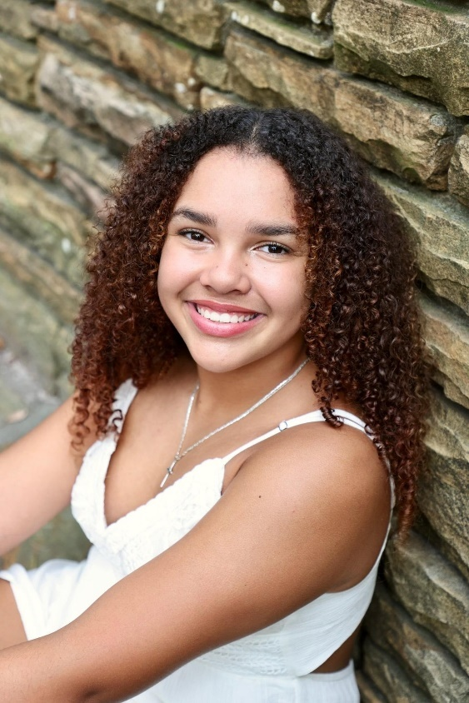

Amira
Lang
5’5
Tampa, Florida
- Contact  Sarah Moss  langamira918@gmail.com  (727)420-9007  - Education  3 Years of Spanish Honors  Accelerated High School Student  Acting Coached by Keri Sullivan  - Skills  Elite Cheerleading, Tumbling, Dance, Conversational Spanish, Saxophone, Drive Standard Vehicle, Hula Hoop, In-Line Skating, Can Recite the Dairy Queen Menu |  | Experience  AllStar Cheerleading & instruction  Florida Top Dog Allstars | Largo, FL| 2017-2025  Levels 1-6 experienced elite cheerleader with tumbling, dance and jumping experience.  3x UCA National Champion  2x All Out Grand National Champion  8x Summit National Qualifier  2x World’s Cheerleading Qualifier  vocal & Band performances  Pinellas Co Public School | Largo, FL | 2022-2023  Five consecutive years of vocal performances as a tenor through the chorus program with 2 consecutive years of band performances playing the saxophone.  Soloist – Three Piggy Opera  Soloist – Lion King  print  Florida Top Dog Allstars | Largo FL | 2022-2025  Professionally photographed and used for print advertisements on social media and company website.

