Acting Resume

Tim Harper

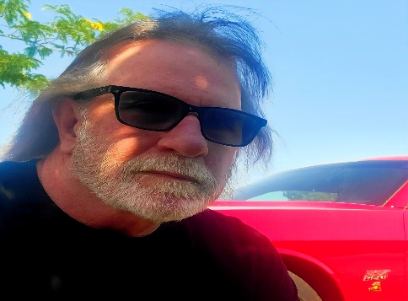

Height: 5’9 Weight: 180 Address: 760e Birch st,
Hair: Brown Eye color: Blue DOB: 10/09/1961 P.O Box 433
EXPERIENCE FILM/TV: Wellington Ut, 84542
I was a cast member in the TV series Yellowstone spin-off “Marshals” where I played the role of a 1%er gang biker nicknamed Savage.
THEATER:
I have no experience currently.
TRAINING:
I have some online acting class training and continue to improve my craft.
SKILLS:
Over 40 years of martial arts training, specializing in motorcycle riding on and off-road, I play guitar and sing country and classic rock, I have shot numerous different types of firearms and ridden horses, specialize in back country mountain survival and technical off-roading, in Jeeps, motorcycles, and hiking. I have done public speaking for large organizations, Elks Lodge and former employers.
GOAL:
My goal is to book work in an old western project or biker gang, 1800s mining project, Viking era, outlaw bad guy etc. and perform, articulate my character to the best of my ability.
CONTACT: (435) 650-0004 Please review my profile on Project Casting.

